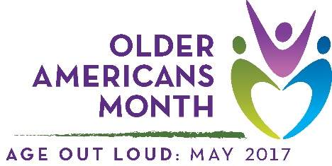

Sample Proclamation
Support from a mayor or governor can raise community awareness about Older Americans Month. Use the proclamation template below to request public recognition by your local government officials.

Older Americans Month 2017
A Proclamation
Whereas, [community, area, or organization] includes older Americans who richly contribute to our community; and

Whereas, we acknowledge that what it means “to age” has changed—for the better.

Whereas, [community, area, or organization] is committed to supporting older adults as they take charge of their health, explore new opportunities and activities, and focus on independence; and

Whereas, [community, area, or organization] can provide opportunities to enrich the lives of individuals of all ages by:
- involving older adults in the redefinition of aging in our community;
- promoting home- and community-based services that support independent living;
- encouraging older adults to speak up for themselves and others; and
- providing opportunities for older adults to share their experiences.

Now therefore, [I/we] of [city/town, state] do hereby proclaim May 2017 to be Older Americans Month. [I/we] urge every resident to take time during this month to acknowledge older adults and the people who serve them as influential and vital parts of our community.

Dated this [day] day of [month], 2017
[Name of person/entity approving proclamation]
[Seal, if applicable]

