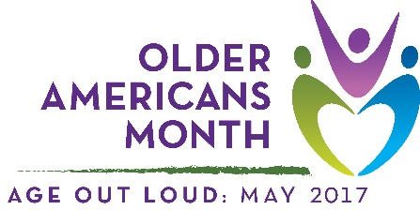

Sample article
This drop-in article can help you raise awareness of and encourage participation in Older Americans Month. Use it as a fill-in-the-blank template or as inspiration for an original piece.

Older Americans Month 2017: Age Out Loud
Getting older doesn’t mean what it used to. For many aging Americans, it is a phase of life where interests, goals, and dreams can get a new or second start. Today, aging is about eliminating outdated perceptions and living the way that suits you best.

Take Barbara Hillary, for example. A nurse for 55 years who dreamed of travel, at age 75 Hillary became the first African American woman to set foot on the North Pole. In 2011, at age 79, she set another first when she stepped onto the South Pole. Former president George H.W. Bush celebrated his 90th birthday by skydiving. Actress Betty White, now 95 years old, became the oldest person to host Saturday Night Live in 2010, coincidentally during May—the same month recognized as Older Americans Month (OAM).

Since 1963, OAM has been a time to celebrate older Americans, their stories, and their contributions. Led by the Administration for Community Living (ACL), the annual observance offers a special opportunity to learn about, support, and recognize our nation’s older citizens. This year’s theme, “Age Out Loud,” emphasizes the ways older adults are living their lives with boldness, confidence, and passion while serving as an inspiration to people of all ages.

[Organization] will use OAM 2017 to focus on how older adults in our community are redefining aging—through work or family interests, by taking charge of their health and staying independent for as long as possible, and through their community and advocacy efforts. We can also use this opportunity to learn how we can best support and learn from our community’s older members.

Throughout the month, [organization] will conduct activities and share information designed to highlight [local programs, resources, stories, etc.]. We encourage you to get involved by [dependent on unique goals/activities].

Join us and ACL as we speak up for #OAM17 and #AgeOutLoud this May!

***

Visit the Official OAM Website
Follow ACL on Twitter and Facebook
Connect with us: [name(s), phone number/email, and social media sites as applicable]
Contact your Area Agency on Aging: Visit http://www.eldercare.gov/ or call 1-800- 677-1116

