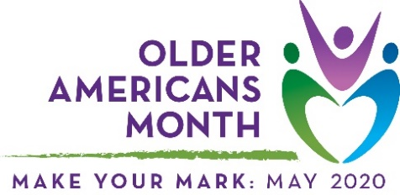

Sample article
This drop-in article can help you raise awareness of and encourage participation in Older Americans Month. Use it as a fill-in-the-blank template or as inspiration for an original piece.

Older Americans Month 2020: Make Your Mark
Around the nation, older adults make their marks every day as volunteers, employees, employers, parents, grandparents, mentors, and advocates. They offer their time, talents, and experience to the benefit of our communities.
For 57 years, Older Americans Month (OAM) has been a special time to recognize these contributions. Led by the Administration for Community Living (ACL) each May, OAM also provides resources to help older Americans stay healthy and independent, and materials to help communities support and celebrate their citizens.
This year’s OAM theme, Make Your Mark, highlights older adults’ unique and lasting contributions to their communities—everything from sharing a story with grandchildren to leaving a legacy of community action. In the spirit of this theme, here are a few ways to make your mark this May and all year long:
Volunteer your time. Local schools, shelters, food kitchens, and hospitals always need support. Help a neighbor by prepping a meal, picking up groceries, or giving them a ride. Or, take time to pass on your knowledge. Why not tutor a student who could use extra help in math, music, or science?
Share your story. There are so many ways to do this, from showing your grandkids around your old neighborhood to writing a book. Take a class and learn how to express yourself with the arts! Or, assemble a photo album of important moments in your life.
Get involved in your neighborhood. Join a homeowner or resident association, organize a block party, or sign up for a book club or other social group. Have a green thumb? Small projects like planting flowers in your yard or cleaning up the community park have a big impact.

Communities that support and include all their members are stronger! Please join [organization/community name] in strengthening our community – [insert call to action, such as events, volunteering opportunities, or social media activities].

Need OAM resources or want to learn more? Visit the official website, acl.gov/oam, and follow ACL on Twitter and Facebook.

