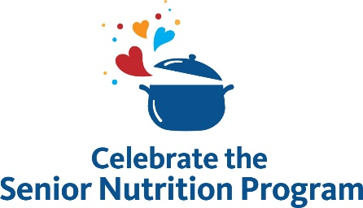

Sample Newsletter/Website Article

Nutrition is a vital component of our health and well-being, especially as we age. But in communities throughout the U.S., older adults sometimes lack access to the high-quality, nutritious food they need to remain healthy and independent.
Funded by the Older Americans Act, the national Senior Nutrition Program has provided nutrition services to older Americans since 1972. The Administration for Community Living (ACL), part of the U.S. Department of Health and Human Services, provides grants to states to enable a network of local programs that deliver nutrition services to older adults. These programs promote healthy eating, foster meaningful social connections, and support overall health. They also act as a gateway to other home and community-based services like falls prevention programs, chronic disease management resources, and more.
This March, [organization name] is proud to celebrate the anniversary of the national Senior Nutrition Program with others across the country. Throughout the month, we will highlight resources on [areas of focus/activity].
We invite you to join us in celebrating our local program by:
- Sharing our [social content, website, article, event registration, etc.].
- Participating in our [class, event, or other activity].
- Educating others so they can understand and use nutrition services.
Learn more about our program and services by contacting [name] at [phone number and/or email].
You can also visit ACL’s celebration webpage and use #SeniorNutritionProgram to join the conversation.

