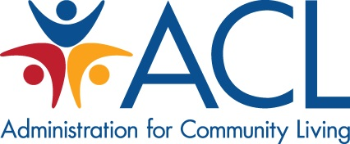

Administration for Community Living Photograph/Video/Testimonial Release
I hereby grant the Administration for Community Living (ACL) permission to use my likeness in a photograph, video, or other digital media (“photo”) and my testimonial (written words) in any and all of its publications, including web-based publications. I agree that ACL may use such materials of me with or without my name and for any lawful purpose without payment or other consideration.
I understand and agree that all materials will become the property of ACL and will not be returned.
I HAVE READ AND UNDERSTAND THE ABOVE RELEASE. I AFFIRM THAT I AM AT LEAST 18 YEARS OF AGE, OR, IF I AM UNDER 18 YEARS OF AGE, I HAVE OBTAINED THE REQUIRED CONSENT OF MY PARENT/GUARDIAN AS EVIDENCED BY THEIR SIGNATURE BELOW. I ACCEPT:
Name: _________________________________
Signature: ___________________________
Address or Email Address: __________________________________
Date: _____________________________________
Name of parent or guardian: __________________________________ (if under age 18)
Signature of parent or guardian: __________________________________ (if under age 18)

