# Leveraging Innovation, Collaboration, and Data with Assistive Technology to Reduce Social Isolation and Loneliness: Success Story from Illinois

**Laura House**, Center for Regional Operations (CRO), Administration for Community Living (ACL)

**Robert Groenendaal**, Center for Innovation and Partnership (CIP), ACL

**William Schutz**, National Institute on Disability, Independent Living, and Rehabilitation Research (NIDILRR), ACL

The purpose of this brief is to highlight a model and innovative partnership at both the federal and state levels to improve the lives of older adults and people with disabilities. Specifically, this effort successfully purchased and distributed technology devices to older adults and people with disabilities served by local agencies and reduced social isolation and loneliness within this group. From the federal end, this partnership was made possible through funds from Coronavirus Aid, Relief and Economic Security (CARES) Act funding and support from the [Assistive Technology program](https://acl.gov/programs/assistive-technology/assistive-technology), [Aging and Disability Resource Centers (ADRCs)](https://acl.gov/programs/aging-and-disability-networks/aging-and-disability-resource-centers), [No Wrong Door (NWD)](https://acl.gov/programs/connecting-people-services/aging-and-disability-resource-centers-programno-wrong-door) system, and [Older Americans Act programs](https://acl.gov/about-acl/authorizing-statutes/older-americans-act) at the Administration for Community Living (ACL) in the Department of Health and Human Services (HHS).

Multiple entities worked together to lead the [Illinois CARE Connections (ICC) program](https://www2.illinois.gov/aging/programs/Pages/Illinois-Care-Connections.aspx) effort including the Illinois Assistive Technology Program (IATP), Illinois Department on Aging (IDoA), and Illinois Department of Human Services (IDHS). Their efforts were significant because the direct purchase of technology directly for consumers is not allowable with Assistive Technology Act funds. This important collaboration provides a concrete example for other states and entities to engage in similar partnerships in the future.

## Key Findings

* A majority of the participants reported feeling less lonely and socially isolated after receiving a technology bundle through the ICC program.
* Participants in the ICC program reported that the technology bundles allowed them to maintain and increase communication and social interaction with their families to combat social isolation and loneliness during the pandemic.

## How the Program Worked

Launched in spring 2020, Illinois CARE Connections (ICC) coordinated a unique effort between aging and disability entities within the state, including the ACL-funded Illinois Assistive Technology Program (IATP), Illinois Department on Aging (IDoA), and Illinois Department of Human Services (IDHS). The program provided technology devices to socially isolated seniors and persons with disabilities in Illinois during the COVID-19 pandemic (ICC, 2021).

The long-standing relationship that the IATP had with the IDoA and the Area Agencies on Aging was the catalyst for the IATP’s decision to address social isolation with access to technology and broadband service. The IDoA engaged the IATP to focus CARES Act funding on providing services to older adults and people with disabilities at risk for social isolation at the onset of the pandemic. While the program measured social isolation in participants at baseline and follow up, the priority focus of this effort was on getting the AT devices in the hands of older Americans and people with disabilities rather than doing an in-depth systematic study.

The IATP was responsible for implementing the ICC program. To be eligible for the program, participants were required to be receiving services through the IDoA or IDHS, Division of Developmental Disabilities (DDD) or Division of Rehabilitation Services (DRS) providers and programs. For IDoA, participants were age 60 or older and receiving services from the IDoA Community Care Program or through one of their Area Agencies on Aging. Participants also reported being socially isolated as a result of COVID-19 and were experiencing loneliness and a lack of connectedness to their communities. Select questions from the UCLA Loneliness Rating Scale were administered when a person was first referred to the program to assess levels of loneliness at baseline.

The ICC program processed referrals and purchased and assembled technology bundles for each participant. The bundles included a tablet device, case, headset, keyboard (if needed), hotspot (if needed), accessible instructions, and any assistive technology needed for access and use. Later in the program, ICC worked with the University of Illinois at Chicago Center on Mental Health Services Research & Policy to include a brochure in the bundles about participating in the Wellness Recovery Action Planning (WRAP) program; an evidence-based, mental illness self-management intervention.

IATP developed an accessible online referral system and webinar trainings for providers within each of the three agencies responsible for submitting the referrals. IATP and the University of Illinois Chicago-Assistive Technology Unit provided telephone technical assistance if the participant required assistance with the tablet bundles in addition to the clear and accessible directions to operate the devices included in the bundle for each package shipped. ICC staff at IATP followed up with participants after they received each bundle and also followed up with participants through direct mailing.

## Participants

Of the 3,307 individuals who received technology bundles, thirty-three percent (33%) were between 61-80 and thirty-two percent (32%) were between 41-60. Another fourth (23%) were in the 21-40 age group, eight percent (8%) were age 81 and older, and four percent (4%) were 20 or younger. There were also important differences between the three referral groups. The participants referred by Aging tended to be older with ninety-six percent (96%) of these participants who were ages 61 and older. Conversely, the participants referred by DDD were most often much younger with almost half (48%) in the 21-40 age range with another thirty-four percent (34%) in the 41-60 range. Fifty-eight percent (58%) of the participants referred by DRS were in the 41-60 age range with another twenty-one percent (21%) age 61-80 and sixteen percent (16%) age 21-40. ICC program participants from the IDoA were all 60 years of age or older as required eligibility for agency services. Program participants were referred based on reports of social isolation, loneliness, and lack of social connectedness due to

COVID-19.

*“Recently receiving an iPad has changed my life! I have been able to write emails, send messages to my sisters, friends and family, and even FaceTime with them, which I have never been able to do before – let alone visit them during the pandemic. I am able to go online to find information and I also take some typing practices. The iPad has completely changed the way I feel spending so much time at home. Thank you for making such a difference.” ---- Rudy*

## Methods

In the ICC program, the sample for this data analysis consisted of 3,307 eligible participants. These participants were approved and provided with technology bundles in Illinois. Thirty-one percent (31%) were from the aging program; thirty-seven percent (37%) were from one disability program, IDHS (DDD); and thirty-two percent (32%) were from a second disability program, IDHS (DRS).

Baseline data was collected on these participants, including demographic data and a loneliness rating score. Follow-up surveys were administered 30 to 60 days after receipt of the technology bundles to determine if pre and post loneliness scores changed. Differences in the loneliness rating scores were also examined across the three groups of participants referred from different agencies by tablet use, instruction time, and prior use.

## Loneliness Scale

The ICC program administered a condensed three-item version of the UCLA Loneliness Rating Scale when a person was first referred to the program to assess levels of loneliness at baseline. The UCLA Loneliness Rating Scale is a 20-item scale designed to measure a person’s subjective feelings of loneliness as well as feelings of social isolation. This scale assesses different dimensions of loneliness: relational connectedness, social connectedness, and self-perceived isolation. The questions include:

1) How often do you feel that you lack companionship? 2) How often do you feel left out? and 3) How often do you feel isolated from others? The three response categories are: hardly ever; some of the time; and often. The scores for each individual question can be added together to provide a possible range of scores from 3 to 9. Scores of 3 to 5 indicate that an individual is “not lonely,” and scores of 6 to 9 mean that an individual is “lonely” (Hughes, Waite, Hawkley, & Cacioppo, 2004).

## Results

Three thousand three hundred and seven (3,307) ICC participants received the technology bundles. Of these, 2,078 were administered pre- and post-loneliness rating scales. A lower score on the loneliness rating scale means that a person is less lonely. **Figure 1** shows an overall decrease in loneliness from 7.1 to 5.2 with an overall mean change of 1.9. In addition, more than half of the total participants (63 percent) reported a decrease in loneliness after receiving the technology bundles.

*“This past year has been so very lonely for me, so I cannot thank the Illinois Care Connections Program enough for the iPad. Among the many features it offers, I have been able to Face Time with my daughter and granddaughter who live in Canada! It has been well over a year since I have had the opportunity to see them in person, and there is no end in sight to the US-Canada border reopening. Being able to use this new technology and seeing their faces has truly been a gift from God.” ---- Laura*

Figure 1. Overall Pre-Post Reduction in Loneliness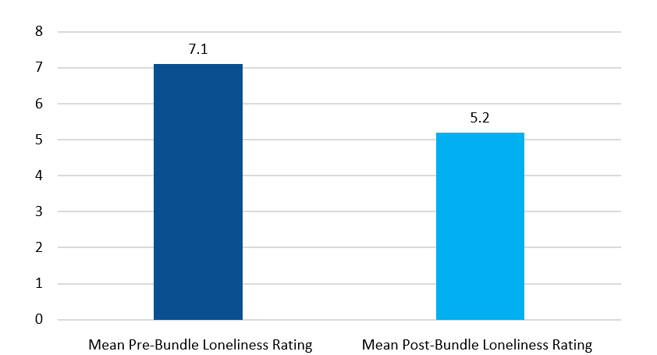

Differences in loneliness were also detected across the referral groups. **Figure 2** shows the pre-post reduction in loneliness scores across the ICC groups. For DDD participants, loneliness scores decreased from 7.4 to 4.7 with improvement of close to three points, with eighty-one percent (81%) rating their loneliness less post intervention with the tablet bundle. For DRS participants, there was also a reduction from 7.4 to 5.4, an improvement of two points with seventy percent (70%) rating their loneliness less post intervention with the tablet bundle. Among Aging recipients, there was also a decrease from 6.6 to 5.8, an improvement of less than one point with thirty-seven percent (37%) rating their loneliness less post-intervention with the tablet bundle.

Figure 2. Pre-Post Reduction in Loneliness across ICC Referral Groups

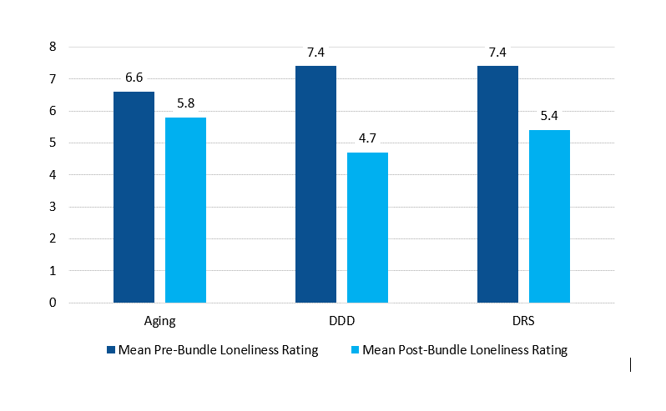

**Figure 3** shows the pre- and post-mean loneliness scores by age group for the overall sample. As shown, there was a decrease in the mean for loneliness from pre- to post-test for all age groups. In addition, the mean for loneliness in the overall sample decreased from 6.69 at pre-test to 6.11 at post-test. The 20 or younger age group experienced the greatest pre- and post-mean change in loneliness of all the age groups.

**Figure 3. Pre- and Post-Mean Reduction in Loneliness across Age Groups**

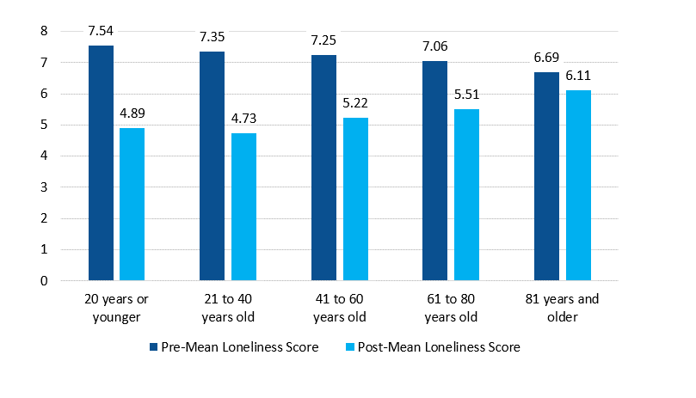

In addition to the participants reporting a decrease in loneliness as a result of receiving the technology bundles, eighty-nine percent (89%) reported that the ICC program filled a critical need by providing technology to address their social isolation that they would not otherwise have been able to access. Ninety-one percent (91%) of the aging participants and DRS participants, respectively, and eighty-five percent (85%) of the DDD participants reported that the ICC program offered the sole opportunity for receiving the technology. Ninety-seven percent (97%) of the ICC participants also reported being highly satisfied or satisfied with the program. High levels of satisfaction were also reported across the referral groups. The participants reported a major benefit from the technology bundles of helping them to maintain or increase their communication with their families.

*“It is incredibly hard for me to be isolated, but the iPad I received from Illinois Care Connections helps me connect with others. My grandchildren have helped me learn how to use this equipment, and we share our days with each other. This is very new for me, but I have enjoyed learning this technology. Hopefully, more of my friends will be able to take advantage of the program, and we can communicate with each other better. Thank you so much for this opportunity.” ---- Clarence*

## Sustainability

The success of the [Illinois CARE Connections Program (ICC)](https://iltech.org/services/icc-aging/) has allowed IDoA to allocate state funding to continue ICC for participants age 60 and above receiving services through the IDoA Community Care Programs. In addition, Illinois is planning to add assistive technology as a service option in its 1915c Medicaid Home and Community Based Services elderly waiver program: the Community Care Program. (Illinois Assistive Technology Program, 2021).

In addition, Illinois has created training materials, including videos that can be accessed by bundle recipients, caregivers and others assisting someone with operating a device. These materials are available for other states and organizations that may wish to replicate and/or customize the State of Illinois’s effort in the future. Some of these resources can be found on the [Illinois CARE Connections Program (ICC) Web page](https://iltech.org/services/icc-aging/), especially the Project Resources and Technical Support Sub-Headings of that page. IATP is always willing to provide technical assistance to support others in replication efforts.

## Connection to ACL Efforts to Reduce Social Isolation

ACL has been in engaged in efforts to combat social isolation among older adults and people with disabilities for several years now. In addition to the unique work of the Illinois Assistive Technology Program and its local aging and disability partners funded through ACL, there are several other ACL-initiated efforts in recent years that address social isolation and loneliness. One effort, the [Commit to Connect](https://acl.gov/CommitToConnect) campaign, a public-private partnership with the AARP Foundation, is building a nationwide network of champions to collaborate on solutions to help reach more people. The project is also developing an online, consumer-focused tool, or clearinghouse that matches older adults and people with disabilities who are socially isolated to customized suggestions for resources that can help them connect and engage with others more frequently and meaningfully. The campaign focuses on establishing critical partnerships in communities and across all levels of government and sharing successful initiatives that can be implemented in communities across the country (ACL, 2021).

A second effort is the National Resource Center for Engaging Older Adults. This national effort focuses on increasing social engagement of older adults, people with disabilities and their caregivers by expanding and enhancing the Aging Network’s capacity to offer social engagement. Specifically, the effort develops and promotes resources that help organizations and communities to increase social engagement opportunities and the size of social networks (USAging, 2021).

ACL’s [National Institute on Disability, Independent Living and Rehabilitation Research (NIDILRR)](https://acl.gov/about-acl/about-national-institute-disability-independent-living-and-rehabilitation-research#:~:text=NIDILRR's%20mission%20is%20to%20generate,for%20its%20citizens%20with%20disabilities.) represents another ACL Center with a targeted focus on addressing social isolation and loneliness through research efforts. NIDILRR funds webinars on social isolation and loneliness research and grants to principal investigators and researchers who conduct studies on social isolation and loneliness for people with disabilities. Examples of recent research grants funded include: studies looking at traumatic brain injury and loneliness; assistive technology during COVID and loneliness; loneliness and healthcare in the United Kingdom; wireless technology to support social connectedness; virtual, home based exercise programs for people with spinal cord injury and their caregivers; and minority student education during COVID-19 on how technology can be a problem and solution (Emerson et al, 2021; Kumar et al, 2020; Bricout, Greer Fields, Xu, Tamplain, Doelling & Sharma, 2021; Donehower, Vinoski, Doulin, Hussain &Jimenez, 2021; Dubois, Bright, & LaForce, 2021).

*“Thank you to the Illinois Care Connections Program! I recently received my tablet, and it has helped me communicate with friends and family during this extremely lonely time due to the COVID-19 pandemic. I’m so grateful as it has allowed me to keep in touch with others as well as stay safe. Additionally, having this device has assisted me while healing from my recent surgery. I’m so excited to have access to my emails, bills, and other applications right in front of me. Thank you again!” ---- Rhonda*

## Discussion

The ICC collaborative effort yielded several important findings and valuable lessons learned that would inform future efforts, especially similar efforts during the current COVID-19 pandemic or crises. These include the following:

1. **Increased awareness:** The ICC program helped to bridge that gap and recognize that the problem of social isolation affects both people with disabilities and older adults. Assistive technology is unique in its ability to serve both populations.
2. **Positive impact of customized technology bundle distribution:** The ICC program demonstrated that the prescription, purchase, provision, and training on the "right AT bundles, customized in the right ways" distributed quickly and efficiently can combat social isolation for older adults and people with disabilities.
3. **Quality of life:** The ICC program identified social isolation and loneliness as serious and growing issues, especially during COVID-19. It also identified a research-supported solution through assistive technology to help address the need and improve the quality of life for two groups in need.
4. **Trusting the evidence:** The ICC program used evidence to inform its approach, design, and methods.
5. **Moving across silos to collaborate within the state:** Three state agencies serving different populations came together to develop and implement an approach and program to address social isolation and loneliness among older adults and people with disabilities. All partners had high degree of confidence and trust in the AT program’s ability to prescribe, purchase, quickly distribute and train users on the use of AT devices and bundles.
6. **High Technology Usage Rates:** Since the AT devices provided to the participants were prescribed, purchased, and provided to users with accompanying training resources by AT experts connected with the Illinois AT Program and the University of Illinois Chicago-Assistive Technology Unit, usage rate was extremely high. The majority of recipients reported using the technology more than 5 times per week and no respondents reported that they did not use the technology at all (thus little abandonment).
7. **Leveraging diverse resources creatively:** While IATP could not utilize Assistive Technology Act funds to purchase assistive technology devices directly for seniors and individuals with disabilities, the ICC program took advantage of the opportunity to utilize CARES Act funding during the pandemic to purchase and quickly distribute this critically needed AT equipment.
8. **Focus on information sharing:**  The Director of the State of Illinois AT Project reached out to other state AT program directors and staff in an effort to discuss common service challenges and to learn about potential solutions to address these challenges. Other State AT programs also reached out to the Illinois AT program to learn about why the provision of AT bundles to older Americans and persons worked and ask for help with technical assistance and available materials to replicate the intervention.
9. **Measuring the impact of the effort:** The ICC program understood how important it was to measure the impact of providing the AT devices to the target populations. Therefore, they identified measures, including a well-respected UCLA loneliness rating scale, developed a pre-post-test design for the analysis, and used bivariate, correlational analyses to conduct the study.
10. **Strengthening the story with context:** Data without context often does not provide the whole story. The ICC program was insightful enough to gather testimonials from participants who benefitted from the technology.

## Conclusion and Implications

Given what is known from the literature about the negative impact of social isolation and loneliness on older adults and people with disabilities, and the exacerbating consequences of the COVID-19 pandemic globally, developing innovative strategies to work collaboratively and efficiently with these populations and others in greatest need is critical. The State of Illinois example provides an excellent blueprint and ultimately achieves positive and impactful outcomes, addresses equity and inclusion issues, and better meets our critical mission of serving and empowering those in greatest need.

*Photo of an Illinois Care Connections Program participant using an iPad.*

*“I just wanted to say thank you so much to the Illinois Care Connections Program for the technology bundle that he received. Words cannot describe how the program has assisted him to stay in touch with our family and participate in programs and services he receives. Thank you again so much!” ---- Dana on behalf of her son*

## Appendix A: Literature Review

### Defining Social Isolation and Loneliness

Social isolation is defined as the “objective state of being isolated from people and lacking meaningful contact with a social network or community” (Shafiq, King, & Rontal, 2020). Loneliness is more subjective in nature and defined as the feeling that one's desired quantity or quality of social connections is unfulfilled (Peplau and Perlman, 1982; Hawkley and Cacioppo, 2010). Social isolation and loneliness have grown alarmingly in prevalence and concern due to the COVID-19 pandemic (U.S. CDC, 2020). This growth has been accelerated by the necessity of lowering the spread of the virus and practicing precautionary measures such as physical distancing, quarantining, wearing masks, and isolation of positive cases (Advancing States, 2020).

For older adults, social isolation and loneliness have been linked to a diverse range of problems, including: reduced happiness, life satisfaction, and psychological well-being; increased depression; compromised physical and mental health; and substance abuse, cognitive impairment and suicide (Holt-Lunstad, Smith, & Layton, 2010; Pantell et al., 2013). Two-thirds (2/3) of older adults in this country report having experienced social isolation since the onset of COVID-19 (AARP Foundation, 2020; Killgore, Cloonan, Taylor, & Dailey, 2020). Individuals aged 65 years and older and individuals with certain underlying medical conditions and chronic disease are at higher risk for severe illness from COVID-19 (US CDC, 2020; Luchetti et al., 2020). Some research suggests that approximately one-fourth (1/4) of community-dwelling older adults are considered to be socially isolated, and 43 percent reported feeling lonely (AARP Foundation, 2018).

For people with disabilities, studies show that they experience higher levels of loneliness compared to the general population. Risk factors for social isolation and loneliness for people with disabilities include living alone, mobility disabilities, and major life transitions, all become more prevalent in older age (Emerson et al., 2021). Specific health risks include increased mortality, increased blood pressure and progression of Alzheimer’s Disease, depression, pain, fatigue, failing immune system, and decreased restorative sleep (Shafiq, King & Rontal, 2020). COVID-19 guidelines that call for social distancing have intensified the social isolation and loneliness faced by individuals with disability, who may be home-bound and have more limited physical functioning.

### Defining Assistive Technology

Assistive technology is any item, piece of equipment, or system, whether acquired commercially, modified, or customized, that is commonly used to increase, maintain, or improve functional capabilities of individuals with disabilities (AT Act of 1998 as amended, 29 USC §3002). Information and communication technology (ICT) include devices and applications such as mobile phones, smartphones, and computers that provide access to information and enable electronic communication (Schlomann et al, 2020). ICT can be especially beneficial for older adults and people with disabilities who may be experiencing social isolation and loneliness due to difficulty communicating with family and friends (Wister, Fyfe & O’Dea, 2021).

### The Significance of Assistive Technology Programs

State and Territory Assistive Technology Programs (AT Programs), authorized under Section 4 of the Assistive Technology Act of 1998, focus on improving the provision of AT through comprehensive, statewide programs that are consumer-responsive. The goal of these programs is to increase access to and acquisition of AT through an integrated set of state-level activities and state leadership activities. Section 4 of the AT Act provides 56 formula grants, administered by the Administration for Community Living, to support an AT Program in each state, as well as the District of Columbia, Puerto Rico, American Samoa, Guam, the Northern Mariana Islands, and the U.S. Virgin Islands (Domin & Shepard, 2021).

Advances in ICT offer new opportunities for people with disabilities in terms of being able to engage in social and cultural activities more fully. Specifically, ICT helps people with disabilities participate in digital communication approaches such as e-learning, teleworking, tele-education, and telehealth opportunities that increases the quality and access to health care services (Mesure, 2016; Moore & Anderson, 2003). However, studies show that adults with disabilities often have unequal access to technology (Shafiq, King & Rontal, 2020). More than half (1/2) of Americans living with a disability report that their disability makes navigating websites challenging. Barriers like this deter them from using technology to stay connected to loved ones and social networks (Shafiq, King & Rontal, 2020).

Similarly, older adults benefit from using ICT in that it helps increase their communication with their family and friends, expand their opportunities for lifelong learning, provide access to health-related information, explore additional resources for personal interests and entertainment, improve quality of life, and support daily activities of living (Chaffin & Maddux, 2007, Gatto & Tak, 2008). A systematic review of 18 research studies also found that ICT significantly reduced loneliness among older adults in less than six months (Chen & Schulz, 2016).

***Special thanks to Kristi Hill, Vicki Gottlich, Richard Wheeler, Lori Gerhard, Amy Wiatr-Rodriguez, and the Illinois AT Program for their important contributions.***

## References

AARP Foundation and United Health Foundation. (2020). The Pandemic Effect: A Social Isolation Report.

AARP Foundation. (2018). A National Survey of Adults 45 and Older: Loneliness and Social Connections.

Administration for Community Living. (2020). Engage Virtually. Washington, DC.

Administration for Community Living. (2020). Strategic Framework for Action: State Opportunities to Integrate Services and Improve Outcomes for Older Adults and People with Disabilities. Washington, DC.

Administration for Community Living. (2021). Assistive Technology Factsheet 2021. Washington, DC.

Advancing States. (2020). Addressing Social Isolation for Older Adults During the COVID-19 Crisis.

Beyer, S & Perry, J (2013). Promoting independence through the use of assistive technology. *Learning Disability Review* (18), 179-185.

Bricout, J., Greer, J., Fields, N., Xu, L., Tamplain, P., Doelling, K., & Sharma, B. (2021). The “humane in the loop”: inclusive research design and policy approaches to foster capacity building assistive technologies in the COVID-19 era. *Assistive Technology*. <https://doi.org/10.1080/10400435.2021.1930282>

Chaffin, A. & Maddux. C. (2007). Accessibility accommodations for older adults seeking e-health information. *Journal of Gerontological Nursing*.33 (3), 61.

Chen, Y & Schulz. P (2016). The effect of information communication technology interventions on reducing social isolation in the elderly: A systematic review. *Journal of Medical Internet Research*, 18 (1).

Domin, D. & Shepard, J. (2021). AT Act Data Brief: A National Data Summary of State Assistive Technology Programs: Fiscal Year 2020. Center for Assistive Technology Act Data Assistance (CATADA), 13.

Donehower, C., Vinoski, E., Doulin, A., Hussain, S. & Jimenez, E, (2021). Using Wireless Technology to Support Social Connectedness in Individuals With Intellectual and Developmental Disabilities: A Focus Group Study. <https://doi.org/10.1177/01626434211004133>

Dubois, E., Bright, D., & Laforce, S. (2021). Educating minoritized students in the United States during COVID-19: How technology can be both the problem and the solution. IT Professional, 23(2), 12-18.

Emerson, E., Fortune, N., Llewellyn, G., & Stancliff, R. , (2021). Loneliness, social support, social isolation, and wellbeing among working age adults with and without disability: Cross-sectional study, *Disability Health J.* 14(1).

Gatto, S. & Tak, S. (2008). Computer, Internet, and E-mail Use Among Older Adults: Benefits and Barriers. *Educational Gerontology.* 34(9), 800-811.

Hawkley, L. C., and Cacioppo, J. T. (2010). Loneliness matters: a theoretical and empirical review of consequences and mechanisms. Ann. Behav. Med. 40, 218–227. <https://pubmed.ncbi.nlm.nih.gov/20652462/>

Holt-Lunstad, J. (2017). The Potential Public Health Relevance of Social Isolation and Loneliness: Prevalence, Epidemiology, and Risk Factors. *Public Policy and Aging Report,* 127-130.

H.R.4278 - 108th Congress (2003-2004): Assistive Technology Act of 2004 www.congress.gov. 2004-10-25. Retrieved 2021-05-13.

Hughes, M. E., Waite, L. J., Hawkley, L. C., & Cacioppo, J. T. (2004). A Short Scale for Measuring Loneliness in Large Surveys: Results From Two Population-Based Studies. *Research on Aging*, 26(6), 655–672. <https://www.ncbi.nlm.nih.gov/pmc/articles/PMC2394670/>

Illinois Assistive Technology Program. (2021). Reducing Social Isolation through Technology: A Report on the Illinois Care Connections Program. Retrieved from:

<https://iltech.org/wp-content/uploads/2021/09/ICC-final-8-24.pdf>

Illinois Care Connections (ICC). (2021). Retrieved from:

<https://www2.illinois.gov/aging/programs/Pages/Illinois-Care-Connections.aspx>

Killgore, W. D. S., Cloonan, S. A., Taylor, E. C., & Dailey, N. S. (2020). Loneliness: A signature mental health concern in the era of COVID-19. Psychiatry Research, 290, Article 113117.

<https://www.ncbi.nlm.nih.gov/pmc/articles/PMC7255345/>

Kumar, R. G., Ketchum, J. M., Corrigan, J. D., Hammond, F. M., Sevigny, M., & Dams-O'Connor, K. (2020). The Longitudinal Effects of Comorbid Health Burden on Functional Outcomes for Adults with Moderate to Severe Traumatic Brain Injury. *The Journal of head trauma rehabilitation*, 35(4), E372–E381. <https://doi.org/10.1097/HTR.0000000000000572>

Luchetti, M., Lee, J., Aschwanden, D., Sesker, A., Strickhouser, A., Terracciano, A., Sutin, A. (2020). The trajectory of loneliness in response to COVID-19. *American Psychologist*. 75(7), 897-908.

Moore, M. & Anderson, W. (2003). Handbook of Distance Education. Mahwah, NJ.: Lawrence Erlbaum. *Am J Public Health.*

Matthew, P., Rehkopf, D., Jutte, D., Syme, S., Balmes, J., Adler, N. (2013). Social isolation: A predictor of mortality comparable to traditional clinical risk factors.103(11), 2056-62.

National Academies of Sciences, Engineering, and Medicine. (2020). *Social Isolation and Loneliness in Older Adults: Opportunities for the Health Care System*. Washington, DC: The National Academies Press. [https://doi.org/10.17226/25663external icon](https://www.nap.edu/catalog/25663/social-isolation-and-loneliness-in-older-adults-opportunities-for-the)

Pantell, M., Rehkopf, D., Jutte, D., Syme, S. L., Balmes, J., & Adler, N. (2013). Social isolation: a predictor of mortality comparable to traditional clinical risk factors. American journal of public health, 103(11), 2056–2062. <https://doi.org/10.2105/AJPH.2013.301261>

Peplau, L. A., and Perlman, D. (1982). Loneliness: A Sourcebook of Current Theory, Research, and Therapy. New York, NY: Wiley.

Shafiq, F., King, J. & Rontal, W. (2020). Social isolation and loneliness are serious health concerns for adults with disabilities. COVID-19 has magnified the problem. Center for Health and Research Transformation: University of Michigan. Retrieved from <https://chrt.org/wp-content/uploads/2021/07/SocialIsolationLoneliness_Accessibility.pdf>

Schlomann, A., Seifert, A., Zank, S., Woopen, C., Rietz, C. (2020). Use of Information and Communication Technology (ICT) Devices Among the Oldest-Old: Loneliness, Anomie, and Autonomy. *Innovation in Aging,* 4, (2), 1–10.

United States Centers for Disease Control and Prevention. (2020). Severe Outcomes Among Patients with Coronavirus Disease 2019. March 27, 2020. Retrieved from

<https://www.cdc.gov/mmwr/volumes/69/wr/mm6912e2.htm?s_cid=mm6912e2_w#T1_down>; accessed May 1, 2020.

USAging: The National Resource Center for Engaging Older Adults - engAGED. (2021). Retrieved from: <https://www.engagingolderadults.org/>

Wister, A., Fyfe, I. & O’Dea, E. (2021). Technological interventions for loneliness and social isolation among older adults: a scoping review protocol. Syst Rev 10, 217 (2021). <https://doi.org/10.1186/s13643-021-01775-6>