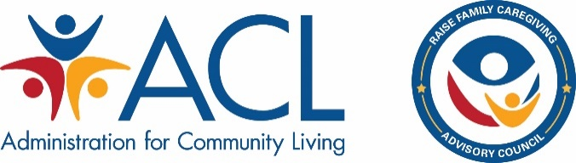

Family Caregiver Advisory Council
Agenda

*Titles and Times Subject to Change

February 11, 2020

1:00 – 1:10 Welcome and Roll Call

1:10 – 1:20 Open and Convening Remarks

1:20 – 1:30 Agenda Overview and Updates

1:30 – 2:00 Decision Making Processes

2:00 – 2:30 Fine-Tuning Our Guiding Principles

2:30 – 3:40 Revise and Expand Goals

3:40 – 4:00 Wrap Up & Overview of Day 2

February 12, 2020

1:00 – 1:15 Welcome, Roll Call, Re-Cap Day 1

1:15 – 1:45 Overview of the Driver Diagram Process

1:45 – 3:30 Establishing a Framework to Achieve Goals

3:30 – 3:45 Outlining Technical Assistance Needs and Future Planning

3:45 – 4:00 Wrap-up and Charge to Sub-committees

