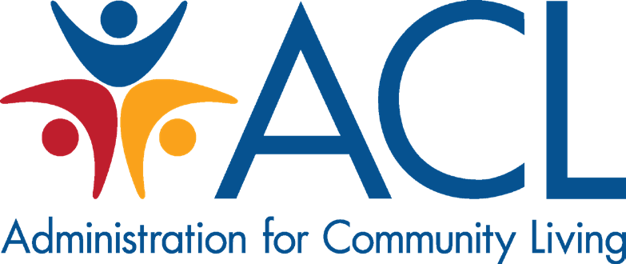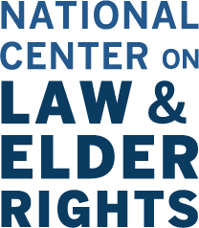

Legal Assistance for Older Americans & COVID-19

Legal assistance providers play an important role in securing and protecting life essentials for older adults, such as access to appropriate housing, income, health care, and protection from abuse. Legal assistance is essential to empower older adults and promote their rights. In health emergency situations, such as the COVID-19 pandemic, legal assistance advocates value the rights and needs of older clients and those who need legal assistance, and at the same time need to attend to their clients’ health and safety, as well as their own health and safety. This means that careful thought must be given to the delivery of legal services, which may need to evolve to minimize risk to both legal assistance staff and their clients, while balancing the ongoing legal needs of the community. Older adults and people of all ages with compromised immune systems are particularly at-risk if exposed to COVID-19, and this resource will offer steps that can reduce health risks while continuing to provide essential legal help.

Personal and Community Safety
Personal and community safety is paramount for older adults and those who serve them. Legal assistance providers are encouraged to review fact sheets and follow directives related to continued operation of business from the Centers for Disease Control and Prevention (CDC) and federal, state, and local governments. As public health guidelines are changing quickly, responding to developing circumstances timely and diligently is important. The Administration for Community Living’s (ACL) webpage on Coronavirus disease 2019 (COVID-19) includes links to resources for older adults as well as information specific to the Aging and Disability Network.

Office Management
The American Bar Association’s publication, Surviving a Disaster: A Lawyer’s Guide to Disaster Planning, provides direction on developing office policies and procedures for emergency response, relocation, remote work, communications, and management structure in the event of a disaster. This information can also be applied to situations involving public health emergencies, including the COVID-19 pandemic.
Older Americans Act Title III-B-funded Legal Assistance programs are urged to communicate with their local Area Agencies on Aging and State Units on Aging to coordinate activities, understand state and local public health directives, and to convey any changes in availability and method of delivery of legal assistance for older adults.

Continuity of Operations
Programs can take steps to ensure that older adults are not unnecessarily subject to exposure to COVID-19, while still having their legal needs met.
Social distancing strategies, as described by the CDC, are necessary to mitigate infections, and these strategies may result in changes in how programs function, such as reduced staff presence at offices or staggering staff presence so fewer are present at any time, and arranging for remote work.

Legal assistance programs can support continued legal assistance work by ensuring that staff have the resources needed to conduct business remotely (see tips in Leverage Technology & Existing Models of Remote Service Delivery).

Priority Setting
Legal assistance providers should consider setting legal case priorities for intake and ongoing representation based on urgency. Some suggested case types to prioritize include:
- Termination of benefits or essential services, particularly those related to health care services, nutrition, and utilities
- Eviction or ejectment from home or nursing facilities, assisted living facilities, and similar residential settings
- Elder abuse or neglect issues with imminent danger and need for immediate intervention
- Cases with upcoming court appearances that cannot be continued without risk of jeopardy to your client (see more in Advocacy for Court Accommodations)
Legal assistance management may consider reallocating attorney and staff time to these urgent cases that require more hours to address remotely and/or to advocate for continuances and other accommodations.
Keep in mind that consent and disclosure obligations continue to apply. NCLER and ACL are available for consultations on these and other matters.

Reduce or Eliminate In-Person Service Delivery & Outreach
To ensure the health of your older clients and promote social distancing, you should take steps to reduce or eliminate in-person service delivery, such as:
- Temporarily suspending home visits with clients
- Arranging for phone communications rather than in-person office meetings, or use Skype, Zoom, or other similar tools if available
- Utilizing mail, fax, and email communication to exchange documents with clients
- Cancelling outreach and community education events (subject to local government directives on public gatherings)
- Conducting help desk and help center activities remotely
- Working with local long-term care Ombudsman programs to facilitate communication with clients in nursing facilities, assisted living, and similar residential settings
- Working with Adult Protective Services to enable your civil representation of elders in immediate jeopardy from abuse, neglect, or financial exploitation

Leverage Technology & Existing Models of Remote Service Delivery
Technology will serve an important role in continuing to serve older adult clients in a health crisis or disaster situation. Pro Bono Net’s guide, Remote Legal Support: A Guide for Nonprofit and Pro Bono Innovation offers suggestions for utilizing tech tools to provide remote service delivery. Some options to consider include:
- Video-based conferencing (for intake, client communication, and pro bono work)

- Walking clients through Law Help Interactive self-help forms and pages by phone
- Utilizing online intake
Leverage senior legal helplines and general legal helplines to provide legal advice and information, as well as to help with intake and referrals of cases in need of full or extended legal representational services. Telephone service delivery may be the best form of remote service to provide to older adults who may not have internet access in their home.
For staff who will be working from home, legal assistance providers should consider the tools they may need:
- Appropriate technology, including laptops or tablets, printers, internet access, phones, etc.
- Access to case management systems to see case notes, calendars, and run conflict checks
- Access to services needed to assist clients with disabilities or with limited English proficiency (i.e.: interpreter services)
- Hard copies of contact information for colleagues, program leadership, key partners, and referral sources, including the Ombudsman program, Area Agency on Aging contacts, State Unit on Aging, Adult Protective Services, and others
- Legal research tools and electronic access to laws, regulations, program policies and procedures, including office emergency preparation and response policies and procedures
- Access to print and online outreach materials such as business cards, program brochures, and educational materials
- Program forms, such as retainer agreements, consent forms, and disclosure forms

Communications
Legal assistance providers may also take steps to communicate their changes to service delivery and availability to the community and their partners. It is important that older adults and people with
compromised immune systems are aware that they can access legal assistance without going to an office or help desk. Consider using the following communications channels:
- Using your social media accounts
- Communicating through local media announcements and articles
- Placing a message prominently on your website homepage
- Sending e-mail to community partners
All of these strategies can help older adults seeking your services to know how to contact you without risk to their health and safety.

Advocacy for Court Accommodations
Many courts are limiting cases and appearances in some manner and some have temporarily closed. It is essential that legal assistance providers advocate for their older adult clients to have limited exposure to these public spaces. Methods can include:
- Requesting accommodations for video or phone appearances in cases where personal appearance is required
- Utilizing affidavits or documentary evidence to enable the court to rule without personal appearance

- Requesting continuances
Legal assistance providers should remain updated on court procedures and policies, as they are changing frequently. Additionally, communication with court administration officials may be necessary to ensure that courts are considering the needs of older adults in their development of new policies.

Continued Support & Technical Assistance
The National Center on Law & Elder Rights is available to provide technical assistance and consultations on issues involving COVID-19 and service delivery to older adults.
Contact them at ConsultNCLER@acl.hhs.gov to request assistance. NCLER can also connect you to ACL’s elder rights team, or contact them directly.

Resources
- Administration for Community Living: COVID-19 Resources
- Centers for Disease Control & Prevention COVID-19 Resources

Case consultation assistance is available for attorneys and professionals seeking more information to help older adults. Contact NCLER at ConsultNCLER@acl.hhs.gov.

