Engage Virtually

Tips for keeping older adults connected

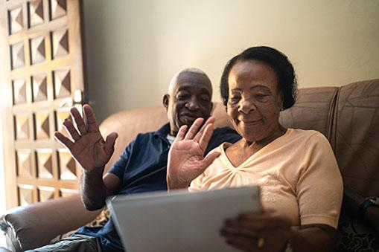
(Family Features) Connection and a sense of community can be critical to well-being as people continue to distance and isolate. It can be challenging, especially for older adults, but there are ways to engage, explore, and unwind.

There is no one-size-fits-all solution, so choose a few things that suit you and commit to them. Remember to pay attention to your social and mental health while taking care of your physical health, and consider these ideas from the Administration for Community Living.

Connect
- Use social media to stay in touch with friends and loved ones or reconnect with people you haven’t seen in a while.
- Take advantage of video call platforms to see faces of family and friends while you talk to them.
- Write letters to friends and reminisce about some of your favorite memories. Ask them to write back and share their own favorite memories.
- Keep up to date with current events and stay connected to neighbors by reading local newspapers and community bulletins.

Explore
- Take free courses online. With subjects ranging from computers and cooking to studio arts and foreign languages, there is something for nearly everyone.
- Explore zoos and aquariums across the country through virtual tours and lessons. Many have live webcams that allow you to watch the animals in real time.
- Enjoy artwork from around the world. Thousands of museums and galleries are currently displaying their collections online through virtual tours.
- Tour one of the many national parks offering digital tours and experiences you can access anytime from the comfort of home.

Unwind
- Check your library’s free e-books and audiobooks you can borrow without leaving home. Consider joining a virtual book club to connect with others enjoying the same book.
- Host dinner or a game night with friends over a video chat. Word, trivia and acting games tend to work well virtually.
- Catch free performances online. Some opera houses and theaters are streaming plays and performances for digital audiences.
- Watch a TV show or movie while talking to a friend on the phone or over video chat. Many streaming services offer free trials and some even have a way to watch together online.

For information on services for older adults in your community, contact the Eldercare Locator at 1-800-677-1116 or go to eldercare.acl.gov.

