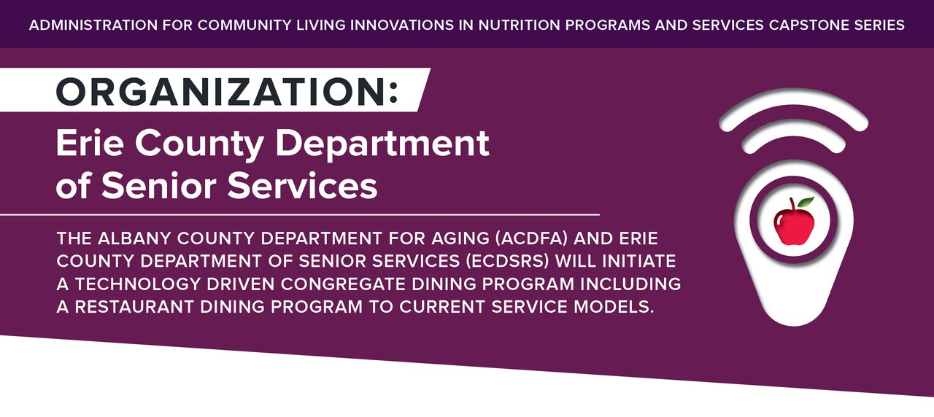

SCHEDULE E-Remuneration Schedule
Administration for Community Living Innovations in Nutrition Programs and Services Capstone Series. Organization: Erie County Department of Senior Services. The Albany County Department for Aging (ACDFA) and Erie County Department of Senior Services (ECDRS) Will Initiate a Technology Driven Congregate Dining Program Including a Restaurant Dining Program to Current Service Models.

Restaurant Dining Program

Go & Dine

It is understood by both parties that the County of Erie shall not be obligated in any way to utilize the services of the Agency at any time during the term of this agreement.

If the County utilizes the services of the Agency during the term of this agreement, all payments shall be based on the per meal rate as agreed upon by County and Agency.

Agency will be paid $10 per Breakfast meal served, and $12 per Lunch meal served to registered County Go & Dine program participants per specifications in Schedule A of this agreement.

Payments: Any and all requests for payment to be made per specifications in Schedule A of this agreement. Except as otherwise expressly stated in the Agreement, no payment shall be made by the County to the Agency for out-of-pocket expenses or disbursements made in connection with the contract services to be performed hereunder.

Fiscal Reporting: Agency agrees to establish and maintain separate accounting records for this contractual agreement in accordance with generally accepted accounting principles.

Refund by the Agency: If, upon the expiration of this Agreement, the amount received by the Agency, exceeds the authorized expenditures pursuant to this Agreement, Agency shall remit to the County the amount of such excess within ten (10 ) days upon separate request of the County. The Agency's obligation under this Section shall continue beyond the expiration or termination of this Agreement.

Final Payment by the County: If, upon the expiration or termination of this agreement, the County owes the Agency for contract services, the Agency shall submit an invoice within thirty (30) days after the termination date, in such form and supported by such documentation and certification as the County may require, and the County shall pay the Agency the appropriate amount. The County's obligation under this Section shall continue beyond the expiration or termination of this contract.
The National Resource Center Nutrition & Aging logo.
Administration for Community Living (ACL) logo.
nutritionandaging.org
This project was supported, in part by grant number 90PPNU0001 from the U.S. Administration for Community Living, Department of Health and Human Services, Washington, D.C. 20201.

