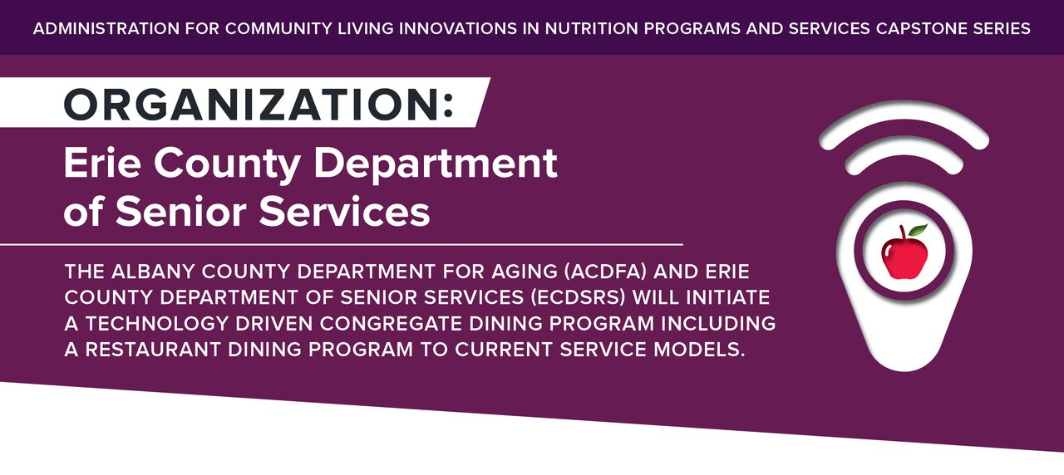

Administration for Community Living Innovations in Nutrition Programs and Services Capstone Series
Organization:
Erie County Department of Senior Services
The Albany County Department for Aging (ACDFA) and Erie County Department of Senior Services (ECDSRS) will initiate a technology driven congregate dining program including a restaurant dining program to current service models.

SCHEDULE A

STATEMENT OF SERVICES

Erie County Department of Senior Services Restaurant Dining Program:

Go & Dine 2019
To the fullest extent applicable, Agency hereby makes the representations and agrees to the terms and conditions set forth in this Schedule:

Services, Terms and Conditions
- Erie County is contracting with the Agency to (A.) Prepare and serve meals to participants of the Erie County Department of Senior Services Restaurant Dining Program: Go & Dine (B.) Evaluate their performance to ensure that all program criteria is met; and (C.) Meet reporting requirements to County as specified herein.
- Agency is responsible for following written policies and procedures concerning all aspects of the program.
- The obligation of the County shall be limited to reimbursement for the price per meal as set forth in Schedule E of this Agreement. The County shall not be responsible for payments to the Agency for any Agency expenditures in violation of this provision.
- Agency will comply with all applicable Federal State and Local laws, rules and regulations (“Law”), including, but not limited to those promulgated by the United States Department of Health and Human Services Administration on Aging, the New York State Office for the Aging, the New York State Department of Health (including Hazardous Analysis Critical Control Points (“HACCP”) procedures) and the Erie County Department of Health, in the performance of this Agreement, including but not limited to the procurement, storage, handling, preparation, cooking, heating, and chilling of meals.

- Agency undertakes and agrees that any program or services facility provided hereunder shall be in full compliance with all applicable laws, regulations, and ordinances respecting health, sanitation, and fire protection, and will supply the Commissioner of Senior Services with proof of such compliance upon request. If said facilities should be cited for violations under these applicable laws, regulations, and/or ordinances, the Agency will be responsible for the correction of such violations as soon as possible after notification and within the period specified in the citation(s). Agency shall forward all notices of violations to the Commissioner of Senior Services within 24 hours of receipt of such violation. Agency represents that all required fire and sanitation inspections have been made and that it has adequately planned for the safety needs of the elderly who are to be beneficiaries of service under this Agreement, and which service is within the contract of the Agency. The Agency agrees from time to time to satisfy the County that adequate provision for such safety needs are in effect. The Agency agrees to procure and keep in effect all necessary licenses, permits and food handler cards required by law, and the Agency agrees to post such licenses, permits, and cards in a prominent place within the site location(s), as required.
- All equipment supplied by the County under this Agreement shall be deemed to be the property of the County and shall be used as far as practical by the Agency, for the purpose of carrying out the extent of the Agreement, and shall not be available for general use by the Agency outside of this Agreement. All such equipment shall be identified in a suitable manner. Upon the termination of this Agreement, if not renewed, Agency shall submit a final inventory of all such equipment on hand within thirty days after completion of the services to be performed under this Agreement. Disposition of the inventoried property shall be made in accordance with applicable provisions of the law under the direction of the County. Agency shall reimburse the County for any loss or damage of said equipment due to fire, theft, or any cause other than from normal use.
- The County and Agency will collaborate during the contract period to evaluate the program and discuss ways to best serve the seniors of the community.
- Appropriate Agency and County staff will meet or teleconference as needed, to review quality control procedures, and make appropriate adjustments in the meal service, food preparation, recipes, or menu.
- Agency is encouraged to attend the quarterly project meeting with County and Congregate site representatives.

- Agency is responsible for performance and compliance of the following:

  - Prepare and Serve Meals to Go & Dine Participants

    - Agency will prepare and serve meals to Go & Dine Program participants.
    - Participants will be registered by Erie County Department of Senior Services staff.
    - Participants will be issued a program key tag and a minimum of four (4) meal vouchers per month.
      - Key tag and voucher have matching participant numbers
      - Participants may use their vouchers at any Go & Dine restaurant site
      - Voucher issuance and use may be phased out in the future, and number of meals available to participant stored in key tag data. Agency will be notified in advance if and when this change occurs.
    - Participants will be provided a menu and program guidelines:
      - Participants must present their voucher and key tag when ordering
        - Agency must verify that the key tag and voucher numbers match
      - “Take out” orders are not permitted
      - Go & Dine meals are only for program participants; if a meal is claimed for another, participant may be removed from the program.
      - Voluntary contributions to County Nutrition services are not to be collected at the restaurant
        - If Participant asks about contributing, they should be advised to call Senior Services Information and Assistance at (716) 858-8526
          - All County Nutrition program participants are given information about voluntary contributions which help sustain and expand these programs
    - Participants may choose one meal per visit from the menu devised collaboratively by County and Agency.
      - Meal is at no cost to the Go & Dine participant
        - If participant orders any additional menu item, participant is responsible for that charge out of pocket.
        - The County does not provide a gratuity through this program. Any gratuity provided is the sole responsibility of the program participant.
      - When “cashing out” a participant, Agency must scan the barcode provided by the County first, then scan the Participant’s key tag

      - Participant must hand in a Go & Dine voucher
        - Agency must write the name of the Restaurant and the date of the transaction on the voucher
        - Vouchers must be submitted to the County with weekly invoices (see reporting section below).

    - General Meal Requirements:
      - Meals are provided based on menus developed by the County and Agency.
      - Each complete meal will meet or exceed, at least one-third the recommended daily allowance for adults 60 years of age or older and include a good source of Vitamin C every serving day, a good source of Vitamin A three times per week, and 3oz. high biological value edible protein every day.
      - All menu substitutions must be approved by the County Registered Dietitian. All menu substitutions must be of equal nutritive value.
      - Agency guarantees that all meals will conform to the requirements of the program. This includes the provision that each complete meal must provide 1/3 of the Recommended Daily Allowance for adults 60 years of age and older, as specified by the Food and Nutrition Board, National Academy of Science and the National Research Council. The meal must include a good source of Vitamin C every day, a good source of Vitamin A three times per week, and 3 oz. high biological value edible protein every day.
      - Meals must be moderate in sodium (~1500 mg. /meal or less), saturated fat and sugar levels. No salt may be used in the cooking process. Low sodium products are to be used in gravies, soups, sauces, etc.
      - All meals must be of the highest quality standards and conform to USDA requirements. Meals must be prepared in a manner to preserve optimum flavor, color, texture, size, shape and appearance while retaining nutrients and food value. Agency must ensure entrée tenderness. Agency must sample food items to ensure high quality and entrée tenderness prior to serving.
      - Agency must provide specific recipe information to the county dietitian as required by NYSOFA, as needed, to complete nutritional analysis of all items served for all menus.

      - Agency shall keep full and accurate sales and procurement records related to meals provided to the Agency for purposes of this Agreement. All such records shall be kept on file for a minimum of six years after the end of the federal fiscal year to which they pertain or such longer period as the Administration on Aging, NYSOFA or the County may from time to time reasonably designate in writing.

    - Food Safety and Sanitation:
      - The location where the food is prepared, processed, and/or packaged shall be maintained and operated in compliance with Law, including but not limited to Local and/or State Department of Health regulations.
      - Agency is required to comply with all applicable HACCP procedures and to maintain such records as required by the New York State, Department of Health and to provide such records to the County upon request. The County reserves the right to inspect all aspects of the Proposer’s food preparation, storage and delivery and to require that food that does not meet HACCP guidelines be discarded.
      - Agency is required to abide by staff hygiene and safe food handling practices per Exhibit A herein.
      - All food preparation, storage and distribution facilities, appliances and equipment shall at all times be kept and maintained in a clean and sanitary condition as required by Law and that kitchen appliances and other equipment are kept at all times in good repair for satisfactory operation as required by Law.

  - Monitoring and Evaluation:

    - Quality Assurance:
      - Agency is required have routine quality assurance processes in place to ensure that food is prepared and served in accordance with requirements set forth herein.
    - Quality Improvement:
      - Agency is required to work with the County on quality improvement efforts. Client feedback will be collected on a regular basis through a variety of appropriate means including, but not limited to, surveys and focus groups/interviews with program participants and/or their caregivers.

    - Agency will work in conjunction with the County to inspect and monitor meal preparation, to ensure that food safety, quality, portion control, logistics, as well as all documentation as it relates to food production is in compliance with this agreement.
    - The County is responsible for evaluation of the Go & Dine Program and all services provided in connection with it. The Agency shall cooperate with the County in the conduct of such evaluations that are deemed appropriate from time to time.
    - The ECENS program is committed to ensuring a high level of participant satisfaction with the quality and variety of the food that is served, and with other aspects of service that is provided. Participants are surveyed on a regular basis to assess satisfaction with the program. Agency must assist in the distribution and collection of paper surveys.
    - Agency must partner with the County to review and address issues related to participant satisfaction.
    - Agency should anticipate site visits by the Erie County Department of Senior Services to review such efforts.

  - Reporting

    - Erie County Department of Senior Services staff will exchange scanners, and pick up vouchers and invoices once per week.
    - Agency will be provided a receipt stating the date, Agency name, and number of vouchers received that week.
    - Payment will be issued to the Agency approximately 2-3 weeks after invoices are submitted.
    - In addition to the aforesaid reports, Agency shall provide such written reports to the county as may be required by Law and/or as the County may reasonably request in writing with respect to specific issues or questions regarding the services provided pursuant to this agreement.

The National Resource Center on Nutrition & Aging
Administration for Community Living
Nutritionandaging.org
This project was supported, in part by grant number 90PPNU0001 from the U.S. Administration for Community Living, Department of Health and Human Services, Washington, D.C. 20201

