Food Insecurity & Malnutrition Webinar Tip Sheet
Note: The following information is from a March 2021 ACL webinar series, Nutrition, Socialization, and Health & Well-Being. To view the webinars, visit acl.gov/SeniorNutrition.

Purpose: Understand what malnutrition and food insecurity are, the root causes of malnutrition, and how to help combat malnutrition and food insecurity

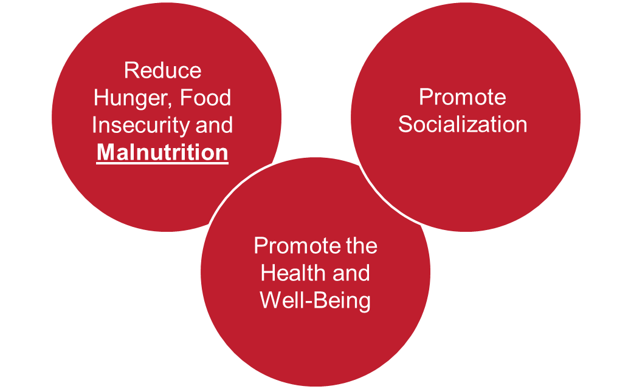
National Senior Nutrition Program
The National Senior Nutrition Program (SNP) is funded by the Older Americans Act (OAA). The program provides older adults with meals and nutrition services and promotes socialization and health and well-being. Learn more about the SNP.

What is Malnutrition?
Malnutrition is a medical condition that involves an imbalance in a person’s nutritional health. It may be related to either under-nutrition or over-nutrition. Malnutrition often goes undetected and leads to an increased risk of illness, falls, and poor quality of life.

Malnutrition in the Aging Population
Malnutrition is a contributing cause of illness and death among older adults. One in two older adults are malnourished or at risk of becoming malnourished. The OAA authorizes health screenings to include screening for malnutrition. SNPs can then refer individuals to additional services, resources, and programs to improve their nutritional health.

Presentation Key Points
- Senior Nutrition Programs should look at the whole person and can identify needs or barriers of the individual and root causes of their malnutrition.
- When talking about access to food, reframe the conversation to include access to nourishing food rather than just access to food.
- To help combat malnutrition, screening, accessibility, education, and program intervention should be implemented.
- Perseverance and partnerships pay off.
- Visibility, credibility, and involvement in policy efforts are important for success.
- Dedication to nutrition security for everyone is vital to successfully address malnutrition and food insecurity.
- Recognition of the importance of nutrition security is growing, which gives rise to new challenges and new opportunities.

Root Causes of Malnutrition
Root causes are underlying factors that cause an issue. Often, there may be more than one root cause. The root causes of malnutrition lead to eating less food, lower absorption of the food that is eaten, or increased calorie needs. Identifying a person’s root causes of malnutrition helps determine the best way to assist them and promote their overall health.

Determinants of Malnutrition in Aged Persons (DoMAP) Model
This Determinants of Malnutrition in Aged Persons (DoMAP) framework diagram, described in detail in the journal Gerontology and Geriatric Medicine, illustrates many potential factors that may contribute to malnutrition. These factors can be generalized as:
- Level 1 – Core issues which lead directly to malnutrition (e.g., low food intake, increased nutritional requirements)
- Level 2 – Cause Level 1 determinants (e.g., lack of food, difficulty with shopping/preparing meals/eating)
- Level 3 – Cause Level 2 determinants (e.g., pain, dementia, poor dentition)
- Level 4 – Cause Level 3 determinants (e.g., frailty, older age, age-related functional decline)

“Enhanced” DETERMINE Checklist to Address Malnutrition
The DETERMINE checklist was created to screen for nutritional risk. This screening checklist is used throughout the United States, including by OAA organizations.

The Greater Wisconsin Agency on Aging Resources, Inc. has developed an “Enhanced” DETERMINE checklist for SNPs and other community-based organizations. This tool can identify root causes that contribute to malnutrition and help staff connect individuals with additional programs and services to lower their nutritional risk.

Food Security vs. Nutrition Security
Food security is having reliable access to a sufficient quantity of affordable, nutritious foods. Nutrition security is having reliable access to a sufficient quality of affordable, nutritious foods that promote well-being and prevent disease. Food programs that address food security tend to focus only on quantity and may not provide nutritious foods or nutrition screening with appropriate referrals.

Medically Tailored Meals
Medically tailored meals (MTM) are meals approved by a registered dietitian that reflect appropriate dietary therapy based on evidence-based practice guidelines. MTM programs, including Project Open Hand, target conditions such as HIV, heart disease, diabetes, chronic kidney disease, and end-stage kidney disease. Studies show MTMs reduce health care costs, lower the rate of hospitalizations and nursing home admissions, and improve control of blood sugar in diabetes.

Partnerships
By partnering with other organizations, SNPs can help fight food insecurity and malnutrition. Partnerships help to bring together consistent data, shared best practices, and collaboration on program issues or ideas.

Some examples of partnerships include:
- Federal Government: Administration for Community Living, U.S. Department of Agriculture, Centers for Disease Control and Prevention.
- National Organizations: Academy of Nutrition and Dietetics, National Council on Aging, Defeat Malnutrition Today, Food Research & Action Council, Feeding America.
- State Government: State Departments of Aging and Disability, Public Health, Veterans Affairs, Social Services, Emergency Management, Agriculture and Health Care Services, Legislators as Champions.
- City and County: Departments of Aging and Disability, Public Health.
- Food companies, suppliers.
- Philanthropies.
- Universities (including Cooperative Extension and SNAP-Ed), health care plans, non-profit organizations, faith-based organizations, hospitals, food banks/food pantries, volunteer organizations.

Definitions

Food Insecurity: When a person is without reliable access to enough affordable, culturally appropriate, nutritious food.

Food Security: When a person has reliable access to a sufficient quantity of affordable, culturally appropriate, nutritious food.

Health Screening: A process that uses questionnaires or procedures to help identify health risks.

Malnutrition: A medical condition that is diagnosed if two or more of the following are present: weight loss, inadequate food intake, reduced body fat, reduced muscle, reduced handgrip strength, and/or swelling due to excess fluid retention.

Malnutrition Screening: Tools (e.g., questionnaires, procedures) used to help assess a person’s risk for malnutrition.

Medically Tailored Meals: Meals approved by a registered dietitian that reflect appropriate dietary therapy based on evidence-based practice guidelines.

Nutrition Screening: Tools (e.g., questionnaires, procedures) used to help assess a person’s nutritional status. Often used to identify food insecurity or risk of malnutrition.

Nutrition Security: When a person regularly has access to sufficient, safe, and nutritious food that meets their dietary needs and food preferences for an active and healthy lifestyle.

OAA: Older Americans Act

Common Warning Signs of Malnutrition: Muscle weakness, fatigue, increased illness or infections, emotional irritability or depression, unplanned weight loss, falls, and decreased appetite.

Resources and Tools
- Nutrition and Aging Resource Center
- Validated Nutritional Risk Screening Tools
- Malnutrition Awareness Week (October 4-8, 2021)
- Mozaffarian D, Fleischhacker S, Andrés JR. Prioritizing Nutrition Security in the US. JAMA. 2021;325(16):1605–1606. doi:10.1001/jama.2021.1915
- Stepping Up Your Nutrition Community-based Workshop
- Eat Well, Age Well, Eat Well, Care Well
- Addressing Food Insecurity & Malnutrition in Older Adults in the Age of COVID-19
- Malnutrition in Community Living Older Adults: A Toolkit for Area Agencies on Aging
- Medically Tailored Meals research
- National Food is Medicine Coalition

This material was developed by ACL Intern Mackenzie Brown, Tufts University, 2021.

