PROCESS EVALUATION – GENERAL GUIDANCE

CHANGE MANAGEMENT

What is change management?
Change management is the discipline that guides how organizations prepare, equip their staff and stakeholders, and support these individuals to successfully adopt needed changes in key aspects of their business process in order to drive organizational success and outcomes.
Source: Prosci: https://www.prosci.com/change-management/what-is-change-management

Why does your nutrition program need a change management strategy?
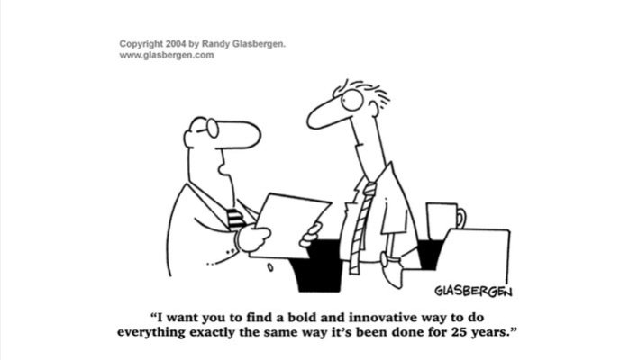
Change is important for any organization because, without change, your nutrition program would likely lose your competitive edge, not embrace new technologies and ways of doing business, fall out of step with the changing business environment and ultimately fail to meet the needs of the seniors and stakeholders you serve. All nutrition programs must proactively adopt change in order to ensure organizational success, viability and sustainability.

What kinds of change management strategies could you use for your program?
There are many ways to shepherd an organization through the changes it will face over its lifecycle as a business such as the following five main approaches.

1. Directive: This strategy highlights the manager's right to manage change and the use of authority to impose change with little or no involvement of other people.

2. Expert: This approach sees the management of change as a problem-solving process that needs to be resolved by an 'expert'. Typically, experts external to the organization are brought in to facilitate and direct the changes made.

3. Negotiated: This approach highlights the willingness on the part of senior managers to negotiate and bargain in order to effect change. In this scenario, the leadership must also accept that adjustments and concessions may need to be made in order to implement change.

4. Educative: This approach involves changing people's values and beliefs, 'winning hearts and minds', in order for them to fully support the changes being made and move toward the development of a shared set of organizational values that individuals are willing, and able to support . Using this approach, a mixture of activities will be used; persuasion; education; training and selection, led by consultants, specialists and in−house experts.

5. Participative: This strategy is characterized by the full involvement of all of those involved, and affected by, the anticipated changes. Although driven by the organizational leadership, the process will be less management-dominated and driven more by groups or individuals within the organization. The views of all will be taken into account before changes are made. Outside consultants and experts can be used to facilitate the process but they will not make any decisions as to the outcomes.

Any one strategy or a mixture of strategies will work for your nutrition program. However it is clear that each of these has pros and cons that could the affect the outcome of the changes you are seeking to apply.

Pros and Cons
Strategy | Advantages | Disadvantages
Directive | Relatively fast | Ignores the view of those affected by the change
Expert | Use relevant expertise  Small groups required  Relatively fast to implement | Experts may be challenged  Resistance of those not consulted
Negotiated | Change recipient have some say  Resistance to change likely to be reduced (or areas of disagreement highlighted) | May be relatively slow  Anticipated change may have to be modified
Educative | People committed to change | Relatively slow  Likely to require more resources and more costs involved
Participative | Change more likely to be accepted  More people committed to change | Relatively slow to implement  More complex to manage  Will require more resources  Increased costs

It is important to be fully cognizant of each strategy’s pros and cons when selecting the strategy or strategies that you wish to apply when designing the change management process for your nutrition program.

Source: Wessex Education Shared Services Ltd Available at: https://www.aoc.co.uk/sites/default/files/Wessex%20Education%20Change%20Management%20Toolkit.pdf
How does change occur in organizations?
Successful change in organizations that leads to overall improvements in performance is driven mainly by each individual within the organization – starting with the organization’s leadership, its internal culture, and the behaviors or day to day choices of each individual or group in the organization. When these factors are all aligned with the change in question, and sufficiently resourced, better performance by the organization impacts its ability to deliver on its stated mission, to execute the its enterprise strategy through leveraging the structure, processes and systems to accomplish the stated change and document impact on the target population(s).

Source: An overall approach to change management. Available at: https://www.strategyand.pwc.com/reports/overall-approach-change-management

Why is understanding my program’s degree of change readiness so important?
Understanding an organization’s readiness for change involves an analysis of the preparedness of the conditions, attitudes and resources needed for the change to happen successfully. The greater the complexity of the proposed change, the greater the importance of understanding where in the system there is readiness for change.

What are the components of organizational readiness?
- Capacity – do we have the staff we need?
- Capability – do we have the skills we need?
- Energy/enthusiasm for change – what is the appetite for the new, different and maybe difficult?
- Progress – are we moving forward, are we future ready, are we successful?

What does organizational culture have to do with it?
Because culture matters! ‘Culture eats strategy for breakfast’ - this phrase, famously attributed to Peter Drucker, a well-known management consultant, educator, and author – alludes to the notion that a sole focus on the how of doing business (the strategy) often comes at the expense of success. Every organization needs the right conditions internally to be in place in order to then support any change to the ways in which an organization does its work.

How can you understand the change readiness of your program?
A simple approach to evaluating your organization is to use the following matrix to compare and contrast three key dimensions of change (attitudes, conditions and resources) across three important aspects of your organization – the larger environment that it resides within (your local business community, competitors, policies, trends, etc), the internal environment to the organization (its culture, policies, governance and resources), and the individuals that will be working to implement the planned changes (staff roles and responsibilities, capabilities, knowledge and skills).

Level  Dimension | Institutional/enabling external environment | Organization/enabling internal environment | Individual-level factors
Attitudes | i.e., statewide transition to managed care – increasing interest address social determinants of health | i.e., culture of continuous improvement | i.e., older volunteer drivers resistant to change
Conditions | i.e., healthcare seeking partnership with CBOs | i.e., establishment of state of the art IT infrastructure | i.e., influx of volunteers seeking opportunities to support organization’s population health management vision
Resources | i.e., local foundation offers grant funds to seed care  coordination partnership between healthcare entities and CBOs | i.e., budget surplus | i.e., veteran client assessor on staff seeking to expand role

How can your program manage staff resistance to change?
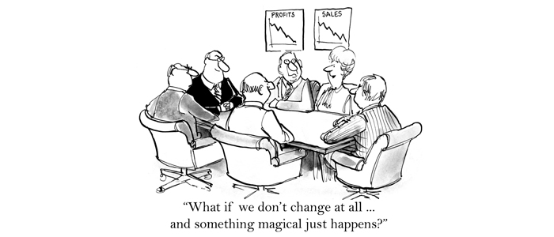
With any of the change management strategies selected, resistance by some individuals or groups to the proposed change is inevitable.

However there are ways in which resistance can be addressed. See the table below.

Tips for Success
- Socialize the idea/change approach with staff, volunteers and Board members
- Constant communication with and engagement of stakeholders
- Words of affirmation – encouragement of key stakeholders. Change is hard.
- Frequent check-ins – taking the temperature of stakeholders. How is it going? What do they need to be successful?
- Be sensitive to how staff prefer to be managed, what they find motivating, and how best to support them through changes in business process
- Identify fears and concerns proactively and providing the necessary steps to addressing them
- Encourage honest and constructive feedback from stakeholders
- Identify and reiterate the opportunity the change offers for improvements in the business at all levels –to the staff, leadership, clients, board members, volunteers, etc.

You are ready to change your organization’s business practice around Client Change of Condition and care coordination. Now what?
Practice Application Exercise: Steps to Change Management
1. Define the Change
Together with your core leadership team, identify the changes to your current business process that will need to be made for your organization to fully adapt this Client Change of Condition protocol.
2. Manage / Identify the Impact of the Change – who’s impacted, how large is the impact
Be clear as you map out the nature of the change to the ways in which your organization manages and attends to client nutrition and social needs, which staff members will be involved in the Client Change of Condition protocol, how the nature of their work will change, what the anticipated reaction to these changes will be, and how your leadership team will collaborate to address their concerns and provide the needed resources to mitigate these changes.
3. Activating the leadership
Working with your leadership team, discuss how you will engage all the members of your delivery team – when they will need to know information, how and how much. Agree on what the messages need to be considering the change management section above.
4. Train right people at the right time and ensure they have the needed supports
Develop a plan with your leadership team on the training that will be needed to implement the Client Changes of Condition – those noted in this resource guide and any additional training that will be needed to ensure that your meal delivery staff have all the information they need to know to be successful.
5. Prepare for the Impact
Identify ways in which your meal delivery and leadership team staff members can report back to you any difficulties or challenges they are having as the Client Change of Condition protocol is rolled out – both feedback that is offered anonymously and feedback for which the authorship is clear.
Source: BUILD Consulting. Change management webinar. https://thisisbuild.com/video-successful-nonprofit-technology-change-management/

PROJECT MANAGEMENT

What is project management? What does it involve?
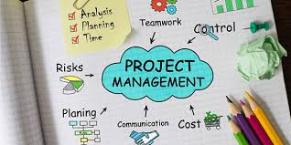
Project management involves the discipline of planning and organizing a project and its resources. In general, project management is comprised of four main elements:
- Needs assessment/Planning
- Executing
- Monitoring and controlling
- Closing

Needs Assessment and Planning
Planning is really about defining fundamentals: what problem needs solving, who will be involved, and what will be done. Identify what the ‘problem’ is that the business practice change is being implemented to address. Sometimes this is not always oblivious. Then, identify who all the stakeholders are. This is often an iterative process to identify all those who will affected by the change that is being implemented, those who will contribute resources (people, space, time, tools, and money), and those who will use and benefit from the project’s output. This phase of project planning also involves determining the goals and objectives of the project. Lastly, it is key to determine scope, and using this, estimate the resources, and major tasks (workstreams) that will ensure the change is successfully implemented.

Monitoring and controlling
This phase of project management involves managing organizational resources to ensure that the needed work is done efficiently and effectively, ensuring that project stays on target with regard to the scope and previously agreed upon goals. Chief among the key tasks for this phases of work include monitoring and controlling project processes and budget, meeting frequently to review how the project is being implemented, reporting on ongoing progress and the achievement of project milestones, and managing and addressing problems should they arise and.

Executing
This phase of the project involves action – translating the project plans into day to day realities for your nutrition program. Key activities that characterize this phase of project management include assembling your team, creating work plans and budgets base done on the project planning activities completed earlier, and ensure that the necessary organizational resources are available to advance the project. Sufficient resources are needed to support cost centers such as personnel, travel, training, supplies, space, research, capital expenditures, and overhead costs.
Closing
In this phase, the activities advanced over the course of the project will need to be brought to a close. This means ensuring that the project outcomes align with initially stated goals and objectives, and meet the need of all project stakeholders. In addition, it will be important to evaluate the performance of those involved in the project, clarify ownership of project deliverables, a plan for disseminating the learnings gained, and decisions about sustaining or terminating the project activities initiated.

COMMUNICATIONS

How and why do organizations communicate? What kinds of communications are there?
Good communication is essential to every organization and facilitates their ability to sell their services to customers, engage and maintain strong relationships with funders, clients and customers.

Internal Communications
This refers to the transmission of messages, facts, opinions, etc between the members of an organization or various units of the organization, for business purposes. Internal Communications work to establish and disseminate the objectives of your organization, and how the organization is functioning relative to the external business environment and in relation to its mission and strategic objectives. Ultimately, these communications can be useful training and engaging staff, Board members, volunteers, and leadership within the organization, and can also serve to motivate them to put their best foot forward within their roles. Internal communications can be either formal or informal in nature. Internal communications include: staff memos or emails, notices hung in public spaces, agenda and meeting minutes, staff meeting presentations and seminars, company manuals and policies, internal company social media messages, etc.

External Communications
External communications are chiefly for the purpose of sharing information between your organization and those external to it, including your clients, supplies, funders, the community at large, government agencies, the general public, etc. This type of communication is formal and largely documented. Its main goal is to assist your organization in maintaining good relationships with stakeholders and maintaining a good public image. Types of external communications include: press releases, annual reports, social and traditional media products, etc.

What kinds of communications could your organization leverage?

Internal
- Staff newsletters
- Staff meetings and trainings
- Volunteer meetings and trainings
- Company manuals and policies
- Presentations to the Board of Directors

External
- Press releases
- Social and traditional media
- Presentations at conferences and meetings
- Company website
- White papers and reports
- Annual report

Key Audiences for Communications
Internal
- Program leaders
- Board members
- Volunteers/drivers

External
- Area Agency on Aging
- Healthcare community – potential or current stakeholders – ACOs, health insurers
- Local newspapers
- Funders – United Way, foundations, banks, etc
- Chambers of Commerce
- Clients
- Local health and aging network associations – area agencies on aging, dietetic, nursing and social work)

What kinds of stakeholders do you collaborate with now?
Which stakeholders does your program currently engage to support your program’s ability to meet the nutrition and social needs? Periodic review of these organizations is helpful to identify relationships that should continue to be nurtured, those that you may need to re-engagement with, gaps in your stakeholder community mix and opportunities that you can pursue to strengthen and grow your partnership community.

These stakeholders may include:
- Board of Directors
- Your organization’s leadership team
- Families
- Hospitals and health systems
- Healthcare professionals – nurses, social workers, care managers, physicians, etc
- Transportation
- Local physician groups, ACOs, PCMHs
- Law enforcement / Adult Protective Services
- Home re-modification programs
- Committees that you serve on – board service, civic groups, etc.
- Funders
- Others: __________________________________________________________

As you review this list, consider the following:
1. Which of these needs to know your adoption of the Client Change of Condition protocol?
______________________________________________________________________________
______________________________________________________________________________
______________________________________________________________________________

2. For whom do you currently, or could you in future, partner with to meet client needs?
______________________________________________________________________________
______________________________________________________________________________
______________________________________________________________________________

3. For those you partner with at present, how and when would you want to raise awareness of your efforts? Which external communication tools would you use?
______________________________________________________________________________
______________________________________________________________________________
______________________________________________________________________________

Timing of Communications – Engagement and Messaging Opportunities
There are some stakeholders that it would make sense for you to engage at different time points as you consider establishing a Client Centered Change of Condition protocol. For some stakeholders, it would be important to engage them early in your process, and other can be engaged at a later date.

Given the relevance the Client Change of Condition protocol has for healthcare entities, it would be important to engage them early in the process. Working together with healthcare payors and providers, you would be able identify their interest in the protocol, the types of data you would be able to identify and what opportunities for collaboration such an initiative can foster for your respective organizations.

Here are possible questions to guide your conversation:
- What kinds of information on client needs would be of value to your organization?
- How are high need individuals flagged or identified by your organization?
- How would your staff welcome receiving information on changes in client health and wellness?
- How can our organizations better collaborate to address both the medical and non-medical needs of the clients we both support in the community?
- What requirements for information sharing does our organization need to be aware of?

Here are some sample communications tools that you can use:
- Sample press release [links to be added]
- Social Media Toolkit [links to be added]
- Local Media Toolkit [links to be added]

If you want more general information, consider this resources:
- Strategic communications for nonprofits – available at: https://exed.annenberg.usc.edu/sites/default/files/Strategic-Communication-for-Nonprofits1.pdf
- Cause marketing – available at: http://causecommunications.org/
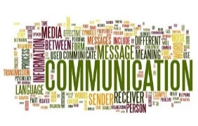

RECORD KEEPING

What is record keeping?
The activity of organizing and storing all the documents, files, invoices, etc. relating to a company's or organization's activities. This is the essential work of every business to maintain and manage the artifacts of its work. This is particularly important for nonprofit organizations and governmental agencies to ensure that they are keeping records in accordance with legal and fiduciary mandates and in such as ways to maintain the public trust.

Records are the memory of a business or business process. They document the information needed for complying with regulations, and the transactions of an organization. Records can have legal, administrative or historical value to your organization.

Records Suggested for the Client Change of Condition Protocol
- Technology Usage Policies
- Care Coordination Protocols

Issue Logs – larger subject
Any issues that come up – staffing, business processes, hardware, injury reporting, software, etc.

Issue Type and Phase | Date Logged | Change Recommended | Action Steps to take | Who is responsible? | Action(s) Taken – type and date | Deadline to complete
I.e., Staff resistance to mobile technology | March 12, 2018 | Additional mobile device training | Reserve room for training April 3, 2018 | Samantha | Room reserved: March 16, 2018 | April 1, 2018
No space for staff to complete data uploads following return to site | March 15, 2018 | Create space in breakroom for meal delivery staff | Create workpace – add office chairs, one desk with charging stations for mobile devices | Suzanne | Chairs on order – March 27, 2018 | March 30, 2018
Etc

Software Error Logs – subset of issue logging
An error or issue log is an information management tool that your program can use to track of issues that arise during the adoption of the Client Change of Condition. Using a tracking system such as this, you will be able to set priorities, documents the status of varies stages of planning and implementation phase of your efforts, start and close dates, and which of your team members is assign which areas of responsibility in your project plan.

Specific to technology

Error Type | Date Logged | Change Recommended | Implications of change +/- | Action Steps to take | Who is responsible? | Action(s) Taken – type and date | Deadline to complete
Pull down menu to select client type (custom menu) alert not functional. | March 22, 2018 | Update / fix the pull down menu | Restores ability to log client information | Reach out to Greg with info on error, screen shot of message and location within app | Jonathan | Email sent to Greg Prosser March 24, 2018  March | March 30 2018
Graphical user interface needs work | March 27, 2018 | Needs to be more user-friendly | Drivers will have an easier time using the application | Reach out to Greg with info on user design needs for interface | Jose | Email sent to Greg on March 28, 2018 | April 6, 2018
Etc

Additional Record Keeping Resources:
- Online template https://www.stakeholdermap.com/project-templates/issue-log.html
- Issue tracker http://www.projectmanagementdocs.com/project-documents/issue-log.html
- Microsoft templates: https://www.stakeholdermap.com/project-templates/issue-log.html

