Meals at Home: How to Access the App Tip Sheet
  - (personal devices)
- In browser type www.ehmah.org.
- Save APP icon to screen on your device.
- Initial sign in: Username and Password are case sensitive.
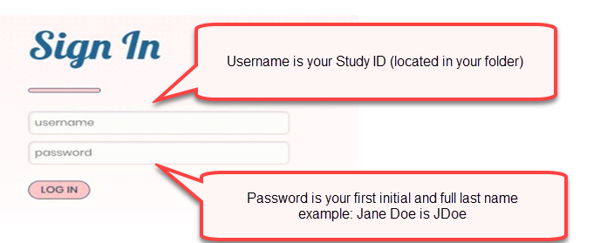
You will only need to sign in once. After this, the app on the personal device will keep you logged in. It does not log you off. Just click on the app and you will automatically be logged in.
- Choosing meals:
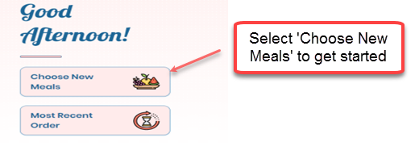
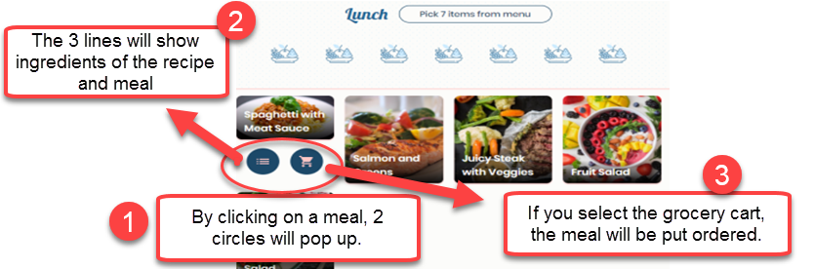

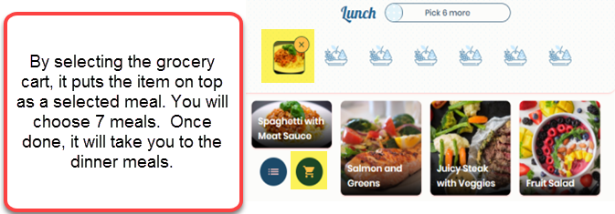
If you would like to take a meal off, just select the “x” by the meal and it will be removed.
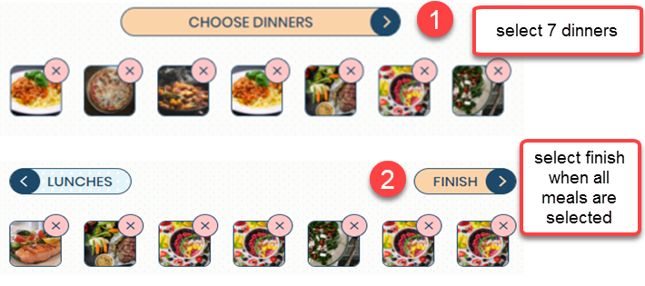
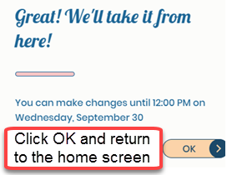

- Reviewing orders:
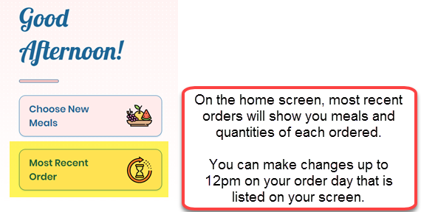
- Reminder, if you are using the app, you just close the app when done, do not log off.
If using a public computer, you will need to log off from the home page.
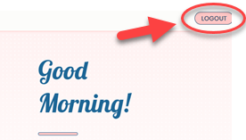
NOTES:
- If no order is placed for the next delivery, your last order will automatically be reordered.
- Please notify Meals on Wheels (317-252-5558) if a week’s delivery needs to be skipped if going on vacation, etc.
- Please contact your social worker regarding any questions accessing the app.

