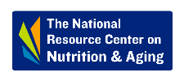

Rhode Island - Project HELLO (Helping Elders Limit Loneliness Outreach)

The development and implementation of Project HELLO, a State Unit on Aging project, is a success story. Due to COVID-19, older adults are staying at home and can become isolated and Project HELLO is part of a multiphase effort to engage older Rhode Islanders. Continuing efforts include working with partners to stand up a virtual senior center, identifying need (connectivity + tech) and leverage funding from local and national resources.

Project HELLO began as a telebuddy system and evolved. Through the state ADRC (The Point), Project HELLO matches volunteers with older adults who would like to “chat”, have a conversation, remain socially engaged. Matching is done based on interests, etc. There are 120 “friends” signed up with 650 volunteers from the State Health Insurance Program (SHIP), Senior Medicare Patrol (SMP), Senior Companion Programs, and others. These are not “wellness” checks, but conversations between “new friends” and occur twice a week. Volunteers just receive a telephone number, they are not expected to shop, run errands, or do other tasks, just be a friend. But because of previous background, volunteers will point them to resources if the “friend” needs something.
As one volunteer said, conversations are getting longer and more far ranging. At first, they were short and people were shy, but now…they hope the program goes on after the emergency passes. And the program benefits both the volunteer and the older adult. 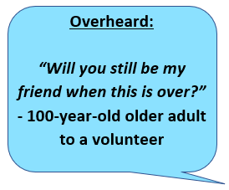

More than one-half of the volunteers have already been vetted (background checks from their current employers or a part of programs where background checks are required). Project HELLO is working with these volunteers first as the others are vetted. Because these volunteers are already part of programs that interact with older adults, no additional training is provided.

The volunteer application form as well as a script for first contact is available at the Rhode Island Office of Healthy Aging website. The contact person for Project HELLO is Elise Swearingen, Community Engagement Director who may be contacted at elise.swearingen@oha.ri.gov.

A recent article appeared in the Providence Journal about the program and can be found at the
Providence Journal website.

