Social Enterprising
Examples from the Network
Featuring: Real Service Area Agency on Aging
November 27, 2020

Aging network providers face financial and organizational challenges serving large numbers of people eligible for the Title III-C senior nutrition program under the Older Americans Act (OAA).
These challenges have been further exacerbated by the COVID-19 pandemic and the aging of America. People age 65 and older are expected to represent 21.6% of the population by 2040.¹ Future emergencies and/or pandemics are not a question of if they will happen, but when will they happen. One thing is for sure, the number of clients served will continue to grow and create challenges.

Network providers have no guarantee increased participants will be supported by increased funding from their local, state, or federal government. The Older Americans Act is a private government pay model that accounts for only about one-third of the total funds spent for each meal, with the remaining two-thirds covered by the state, local, and participant contributions.²

Limited resources (e.g., financial, volunteer, community, capability, and capacity) will impact the ability of SNPs to respond to the increased client need. Social enterprising activities are just one way for SNPs to bridge the gap between what is needed by older Americans and the ability to serve them. Partnerships with state and local governments, philanthropic organizations, and private donors also help expand services. These partnerships allow for an increase in resources for enhanced capacity and quality of operation.

Nutrition providers must innovate their services, menus, and relationships if they are to be effective in serving a growing and diverse older adult population. Now is the time to be bold. Providers must reach and keep new audiences who have been introduced to nutrition services through COVID and secure new ones. They must create expanded collaborations to set a new course for sustainable programs.

The REAL GRILLE FOOD TRUCK
The REAL Grille food truck is a social enterprise business of REAL Services located in South Bend, Indiana. The food truck has been in operation for just over two years. Traveling around the South Bend area, the truck operates March through November serving the general public. All of the REAL Grille profits go directly to fund the REAL Services’ Meals on Wheels Program.

REAL Grille customers (not senior participants) know their purchase benefits the SNP and they are eager to support the cause. Most food items cost about $10 each. The 20-foot vehicle is a state-of-the-art kitchen on wheels. Four staff members work the truck creating a variety of menu items. Gourmet grilled cheese sandwiches are always available along with potato bites, meatless burgers, chipotle chicken tacos, and tomato soup. The menu is ever-changing, but gourmet grilled cheese is always part of the daily offering. REAL Grille encourages local businesses to make a reservation for the food truck to visit their location. They are available for weddings, corporate events, parties, picnics, birthdays, and any events with food.

REAL Grille also provides dinner meals to congregate meal sites for special occasions. Congregate diners can choose among different entrees delivering one-third of the Reference Daily Intake and meeting the Dietary Guidelines for Americans. Dinner meals are available by donation, just like congregate lunches.
CATERING SERVICES

REAL Services also offers catering through their “Simply Catering to You” business. This concept provides robust catering options for large groups and gatherings. All profits fund the Meals on Wheels program. REAL Services rents their kitchen to outside companies during production “down-time.” Kitchen rental doesn’t happen regularly, but when it does, the revenue goes directly to fund Meals on Wheels.

SOCIAL DISTANCING PIVOT

REAL Grille and Simply Catering to You closed operations during the early months of the COVID-19 pandemic as the agency pivoted its attention to feeding all food-insecure people in the region. During that time, they doubled and then tripled the number of meals they delivered. REAL Services became part of the Emergency Food Initiative to discuss and plan feeding thousands of food-insecure people in North Central Indiana. The Kitchen and Transportation staff also helped reduce social isolation by creating a telephone “well check” program. Regularly calling all clients helps them receive vital services or just allows the clients to feel someone was thinking of them. This program proved essential and will remain one of the newly created programs of REAL Services Volunteer programs.
Recently, REAL Grille and Simply Catering to You resumed operations providing the community with their delicious offerings. Private and community events, held outdoors, provided an opportunity for people to socially distance, support a great cause, and eat some great food. Foodservice employees follow COVID-19 precautions mask and social distance from customers.

Learn More About Real Services Area on Aging:
Created in May of 1966 as part of the planning division of United Way, REAL Services is the Area Agency on Aging for the Older Americans Act, administering more than 25 programs designed to help seniors live independently and serves over 30,000 clients a year in 12 counties across northern Indiana. REAL Services is a Senior Nutrition Provider (SNP) through its Meals on Wheels program. The program provides nutritious meals five days a week to older Americans in need.
Questions about the REAL Grille food truck? Please contact George Hawthorne, Director of Nutrition and Transportation, REAL Services. George is available at ghawthrone@realservices.org or 574-284-7146.

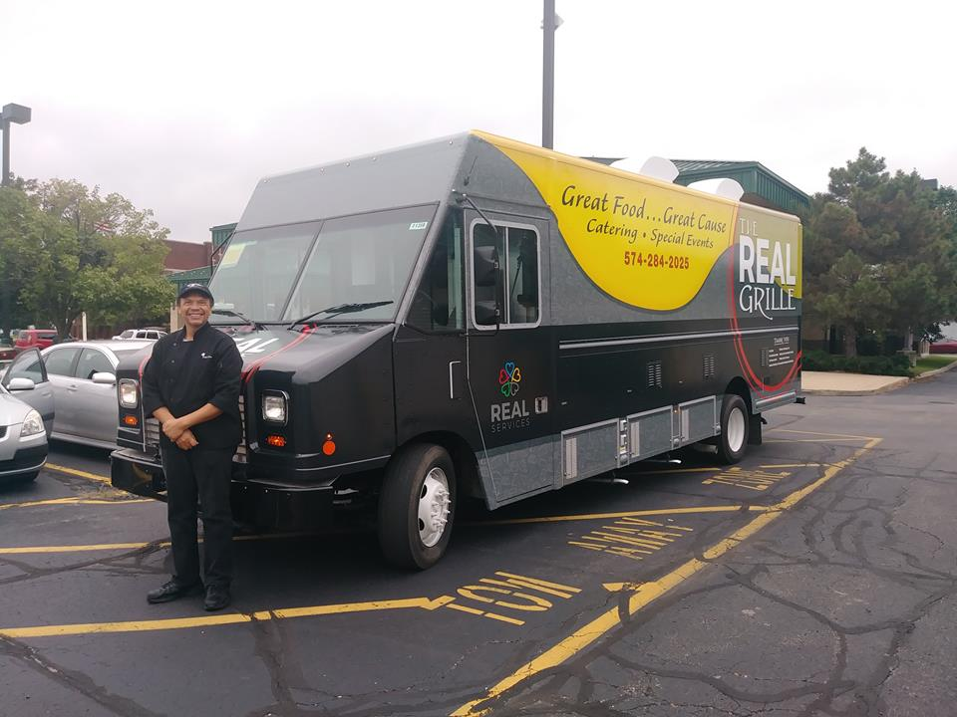
REAL Grille food truck and George Hawthorne, Director of Nutrition and Transportation, REAL Services.

References
¹2019 Profile Older Americans
² Older Americans Act Nutrition Programs Evaluation: Meal Cost Analysis

