
Right Meals for You RED LEVEL
[Organization Logo]

Participants Name: ____________________________________________
Date: __________________

Elder Nutrition Program: Determining Your Meal Needs

Tailored Nutrition
We believe good nutrition and social connection are essential for staying healthy and independent. Through the Older Americans Act (OAA) Nutrition Program, our mission is to reduce hunger, improve nutrition, promote socialization, and support overall wellness for adults aged 60 and older. We offer a variety of meal options and support services designed to meet you where you are. Our goal is to empower older adults to live in their own homes and communities for as long as they wish.

How We Determine Your Needs: “Right Meal & Services for You”
Our "Right Meal & Services for You" Process is designed to determine the most suitable meal option that aligns with your needs, whether it’s:
- Senior Dining Meals
- Grab n’ Go Meals
- Home-Delivered Meals
In addition, we offer a range of programs and services to help you live independently:

- Nutrition Education
- Nutrition Counseling
- Transportation
- Wellness Classes
- Caregiver Support
- Resources and referrals for other programs and services and more!

We’ll work with you to create a plan tailored to your unique situation.

What to Expect from This Process
- Careful Evaluation
We have conducted an assessment to understand your situation and needs.
- Personalized Options
Based on our evaluation, and your input, we’ll recommend the best meal options for you and let you know about any additional services or resources that might be beneficial.
- Ongoing Support
If your needs, situation, or condition changes, please contact us. We’ll reassess you to ensure you are receiving the most suitable support.Here is a summary of your “Right Meal & Services for You” plan.

RED Level Choices
☐ Home Delivered Meals | ______ Days a week
☐ Weekend Meals | ______ Days a week
☐ Frozen Meals | ______ Days a week
☐ Evaluation for Adaptive Equipment
☐ Nutrition Supplement Drink | ______ Per _________
☐ Nutrition Education | Specify: _______________
☐ Nutrition Counseling with Dietitian | Specify: _______________
☐ Meal for Spouse or Person with Disability under 60 | ______ Days a week
☐ Malnutrition Resource Brochure
☐ Emergency Meals & Preparedness Information
☐ Socialization, Nutrition & Wellness Resource Guide
☐ Caregiver Support
☐ Pet Food Assistance ☐ Dog ☐ Cat ☐ Other __________
☐ Other: _______________________________________________
☐ Other: _______________________________________________

Contact Information: For questions or to update us on any changes in your condition or situation.
Thank you for letting us serve you! We would love your feedback. 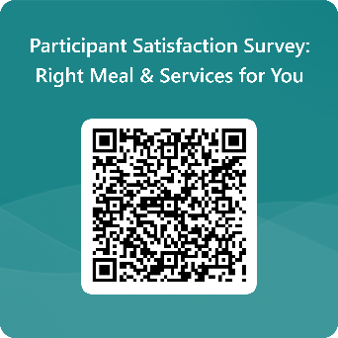

Organization Name: Insert name
Phone: [Your Organization’s Phone Number]
Email: [Your Organization’s Email]
Website: [Your Organization’s Website]

