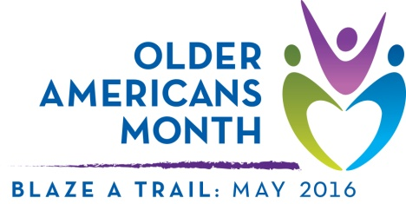

Sample Proclamation
Support from a mayor or governor can increase awareness about Older Americans Month. Use the sample below to request public recognition of Older Americans Month through a proclamation – a government document that officially recognizes an observance in your community.

Older Americans Month 2016
A Proclamation
Whereas, [community, area, or organization] includes a community of older Americans who deserve recognition for their contributions to our nation; and

Whereas, [community, area, or organization] recognizes that older adults are trailblazers—advocating for themselves, their peers, and their communities—paving the way for future generations; and

Whereas, [community, area, or organization] is committed to raising awareness about issues facing older Americans and helping all individuals to thrive in communities of their choice for as long as possible; and

Whereas, we appreciate the value of inclusion and support in helping older adults successfully contribute to and benefit from their communities; and

Whereas, our community can provide opportunities to enrich the lives of individuals of all ages by:
- Promoting and engaging in activity, wellness, and social involvement.
- Emphasizing home- and community-based services that support independent living.
- Ensuring community members can benefit from the contributions and experience of older adults.

Now therefore, [I/we] of [city/town, state] do hereby proclaim May 2016 to be Older Americans Month. [I/we] urge every resident to take time this month to acknowledge older adults and the people who serve them as powerful and vital individuals who greatly contribute to our community.

Dated this [day] day of [month], 2016
[Name of person/entity approving proclamation]
[Seal, if applicable]

