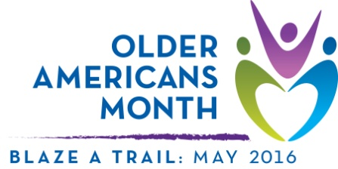

Sample article
This drop-in article can help you raise awareness of and encourage participation in Older Americans Month. Use it as a fill-in-the-blank template or as inspiration for an original piece.

Older Americans Month 2016: “Blaze a Trail”
Older adults are a growing and increasingly vital part of our country. The contributions they make to our communities are varied, deeply rooted, and include influential roles in the nation’s economy, politics, and the arts. From 69-year-old NASA Administrator Charles Bolden, Jr. to 84-year-old actress Rita Moreno to 83-year-old Ruth Bader Ginsberg, who took her seat as a Supreme Court Justice at age 60, older adults are blazing trails in all aspects of American life.

In 1963, we began to acknowledge the contributions of older people by using the month of May to celebrate Older Americans Month (OAM). Led by the Administration for Community Living, the annual observance offers the opportunity to learn about, support, and celebrate our nation’s older citizens. This year’s theme, “Blaze a Trail,” emphasizes the ways older adults are reinventing themselves through new work and new passions, engaging their communities, and blazing a trail of positive impact on the lives of people of all ages.

While [organization] provides [statement of services] to older adults year-round, we will use OAM 2016 to focus on how older adults in our community are leading and inspiring others, how we can support and learn from them, and how we might follow their examples to blaze trails of our own. Throughout the month, [organization] will conduct activities and share information designed to highlight [local programs, resources, success stories, etc.]. We encourage you to get involved by [dependent on unique goals/activities, but may include sharing stories, volunteering in the local area, or attending an organization event].

***

Discover OAM: Visit http://acl.gov/olderamericansmonth
Learn more: Contact [name and phone/email]
Connect: Follow us on [social media sites as applicable]
Contact your Area Agency on Aging: Visit http://www.eldercare.gov/ or call 1-800- 677-1116

