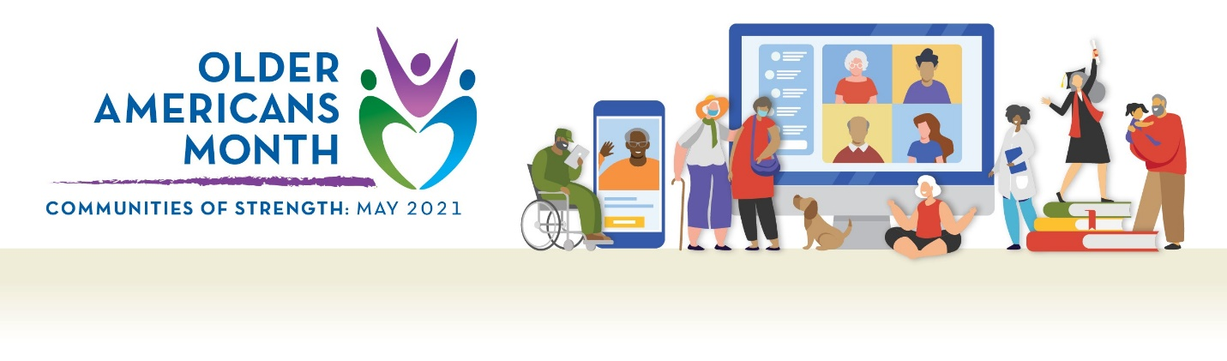

Pen Pal Writing Ideas

For anyone:
- What do you see as your biggest accomplishment? What obstacles did you overcome to achieve it?
- Who or what have you missed most during the pandemic? What have you done in place of seeing them or doing that activity?
- Did you take on a project, develop a new hobby, or learn a new skill during the past year?
- What are your goals for this coming year?

For older adults:
- What would you tell your 20-year-old self?
- What do you think your 20-year-old self would tell you now?
- What lessons have you learned from tough times in your life? How have those experiences made you stronger?

For younger adults:
- What have you learned from your elders? How has it shaped your experiences?
- What questions would you like to ask people who have lived through tough times?
- When you are older, in what ways do you think you’ll be different? In what ways do you hope you are the same?

