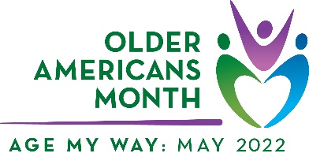

Older Americans Month Sample Article

Older adults play vital, positive roles in our communities – as family members, friends, mentors, volunteers, civic leaders, members of the workforce, and more. Just as every person is unique, so too is how they age and how they choose to do it – and there is no “right” way. That’s why the theme for Older Americans Month (OAM) 2022 is Age My Way.

Every May, the Administration for Community Living (ACL) leads the celebration of OAM. This year’s theme focuses on how older adults can age in their communities, living independently for as long as possible and participating in ways they choose.

While Age My Way will look different for each person, here are common things everyone can consider:

- Planning: Think about what you will need and want in the future, from home and community-based services to community activities that interest you.
- Engagement: Remain involved and contribute to your community through work, volunteer, and/or civic participation opportunities.
- Access: Make home improvements and modifications, use assistive technologies, and customize supports to help you better age in place.
- Connection: Maintain social activities and relationships to combat social isolation and stay connected to your community.

This year, [organization name] is excited to celebrate OAM with our partners in the aging community. Follow along throughout the month to find resources on aging in place, [sub-focus], and [sub-focus].

Diverse communities are strong communities. Ensuring that older adults remain involved and included in our communities for as long as possible benefits everyone. Please join [organization name] in strengthening our community: [insert call to action (e.g., join a virtual event or engage in social media activities].

[Optional: contact person(s), social media links, specific resources, and/or general website]

For more information, visit the official OAM website, follow ACL on Twitter and Facebook,
and join the conversation using #OlderAmericansMonth.

