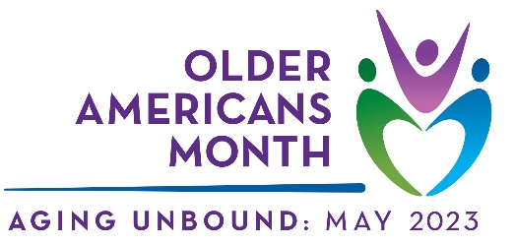
Sample Aging Network Article

Established in 1963, Older Americans Month (OAM) is celebrated every May. Led by the Administration for Community Living (ACL), OAM is a time for us to acknowledge the contributions and achievements of older Americans, highlight important trends, and strengthen our commitment to honoring our older citizens.
This year’s theme, Aging Unbound, offers an opportunity to explore a wide range of aging experiences and to promote the importance of enjoying independence and fulfillment by paving our own paths as we age.
This May, join us as we recognize the 60th anniversary of OAM and challenge the narrative on aging. Here are some ways we can all participate in Aging Unbound:
- Embrace the opportunity to change. Find a new passion, go on an adventure, and push boundaries by not letting age define your limits. Invite creativity and purpose into your life by trying new activities in your community to bring in more growth, joy, and energy.
- Explore the rewards of growing older. With age comes knowledge, which provides insight and confidence to understand and experience the world more deeply. Continue to grow that knowledge through reading, listening, classes, and creative activities.
- Stay engaged in your community. Everyone benefits when everyone is connected and involved. Stay active by volunteering, working, mentoring, participating in social clubs, and taking part in activities at your local senior center or elsewhere in the community.
- Form relationships. As an essential ingredient of well-being, relationships can enhance your quality of life by introducing new ideas and unique perspectives. Invest time with people to discover deeper connections with family, friends, and community members.
[Optional: Local contact person(s), social media links, specific resources, event notices, and/or general website along with any calls to action]
For more information, visit the official OAM website, follow ACL on Twitter and Facebook, and join the conversation using #OlderAmericansMonth.

