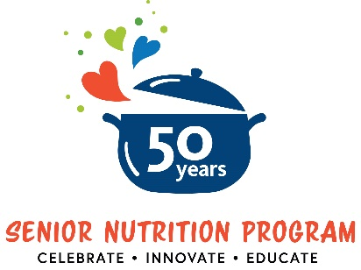

Senior Nutrition Program 50th Anniversary

Sample Newsletter/Website Article

Nutrition is a vital component of our health and well-being, especially as we age. But in communities throughout the U.S., older adults sometimes lack access to the high-quality, nutritious food they need to remain healthy and independent.
Since 1972, the national Senior Nutrition Program has been there to support older adults by providing nutrition services across the country. Funded by the Older Americans Act, the Administration for Community Living (ACL) provides grants to states to support a network of local programs that deliver nutrition services to older adults. These programs promote healthy eating, decrease social isolation, and support better health. They also provide a gateway for older adults to access other home and community-based services such as falls prevention programs, chronic disease management services, and more.
This March, [organization name] is proud to celebrate the 50th anniversary of the national Senior Nutrition Program with others across the country. The theme for the 50th anniversary celebration is Celebrate. Innovate. Educate. With this theme, we in invite you to join us in:
- Celebrating the many accomplishments of senior nutrition programs over the past 50 years.
- Highlighting innovative approaches that have been used to support seniors.
- Educating communities so that they can understand and use nutrition services.
Throughout March, [organization name] will be sharing resources on nutrition, social isolation, well-being, and more. You can celebrate with us by [insert call to action: participating in March anniversary activities (list out), following us on social media, joining us for a virtual event, etc.].
OPTIONAL: Learn more about our program and the services we provide by contacting [name] at [phone number and/or email].
Visit ACL’s Senior Nutrition Program 50th Anniversary website to learn more about this important milestone and join the conversation on social media using hashtag #SNP50.

ACL is an operating division of the U.S. Department of Health and Human Services.

